Diploma in Business Informatics

ITP281

E-Business & Project

E-Business Final Report

ITP281-ZC

Team 4

Tan Wei Jun, Terris (172737L)

Elina Ek Pei Shan (173194P)

Cleyshire Cheng Rui Ning (173419K)

Muhammad Adil bin Sabarudin (175476H)

Mr Ong Teck Kiat

## **Contents Page**

Table of Contents

**Contents Page** 1

**System Overview** 2

**Business Function Overview** 2

**Multi-Tier Architectural Design** 3

**Database Schema** 4

**User Guide - Step-by-Step Guide** 5

**Staff** 5

**User** 23

**Doctor** 37

**Personal Reflection** 42

**Terris:** 42

**Cleyshire:** 43

**Elina:** 43

**Adil:** 44

**Appendix** 45

## 

## **System Overview**

### **Business Function Overview**

**Business Functions:**

* 24/7 Online doctor
* Online store

**24/7 Online Doctor:**

The Online Doctor enables users to consult a doctor at anytime of the day. They can book a doctor through the online booking system by selecting a available date made by the doctor. After the user select their desired time slot, they will have to go to the chatroom for the consultation on the day of the consultation. The chatroom is a platform where the user can communicate with the doctor and start their consultation. In order, for the user to enter the chat room, they will have to enter the room password that is dedicated to that consultation chatroom. The 24/7 Online Doctor service is a paid service provided by Mum’s Story. Our Online Doctor services requires users to already have $30 of E-Wallet funds to make a booking. Therefore, the Online Doctor can serve as an alternative for parents when they need to consult a doctor at home. Doctors we hire will have to go through a background check and must be certified by the Singapore Medical Council as we only wish to bring our customers service of the highest quality.

**Online store:**

The Online Store is a feature that we have implemented into our website to allow users to purchase baby products that they need. Parents can also consider the products that the doctor recommend after the consultation ends. They may also visit the online store at anytime of the day. The store will be selling basic baby necessities such as basic medication, clothes and many more. The online store can also be used with the E-wallet to ensure smooth transactions online. However, keying of credit card details is also still an existing alternative. For our store, we have cut out the middleman, hence we are able to make more profit. We also have a sponsor products section for any future sponsors that would like to sponsor Mum’s Story. Therefore, our competitors will be unable to compete with our wide variety of items. Items bought from the store will also be delivered to the buyers’ keyed address within one week.

### **Multi-Tier Architectural Design**

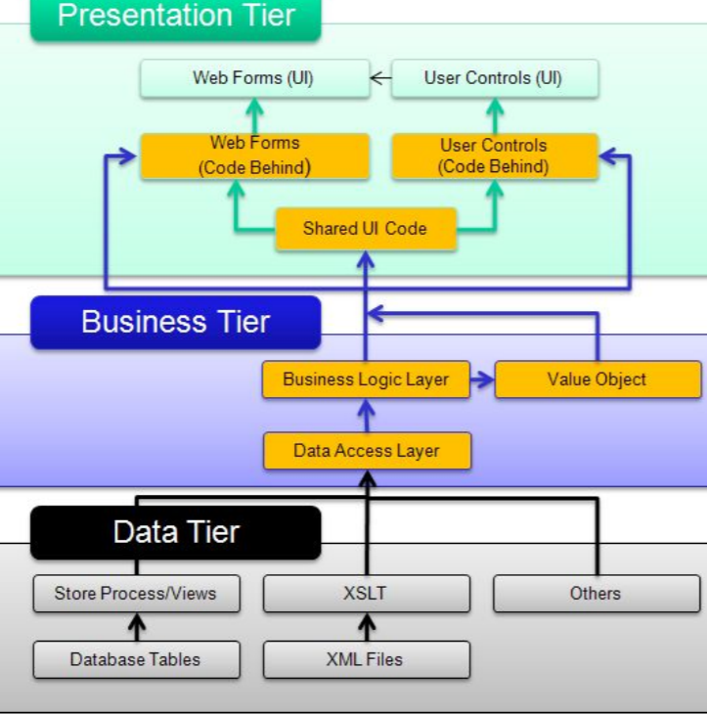

### **Database Schema**

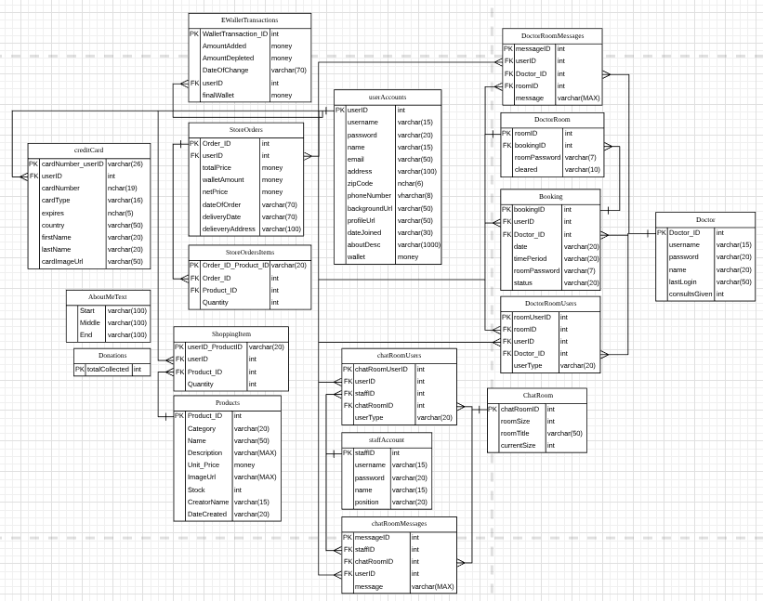

## **User Guide - Step-by-Step Guide**

### **Staff**

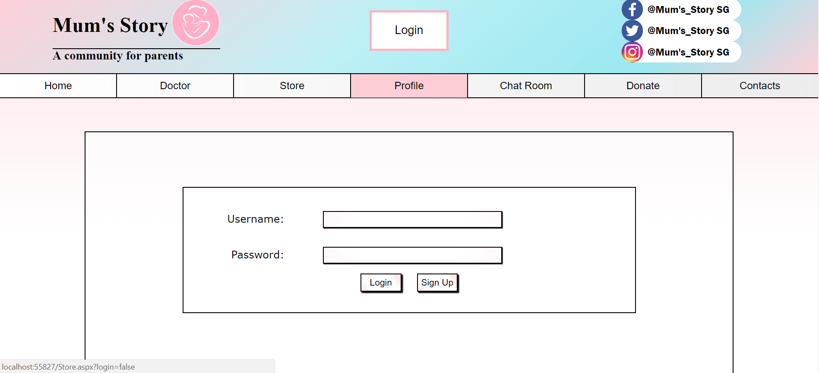

**1.** The staff will first have to log in with their staff username and password.

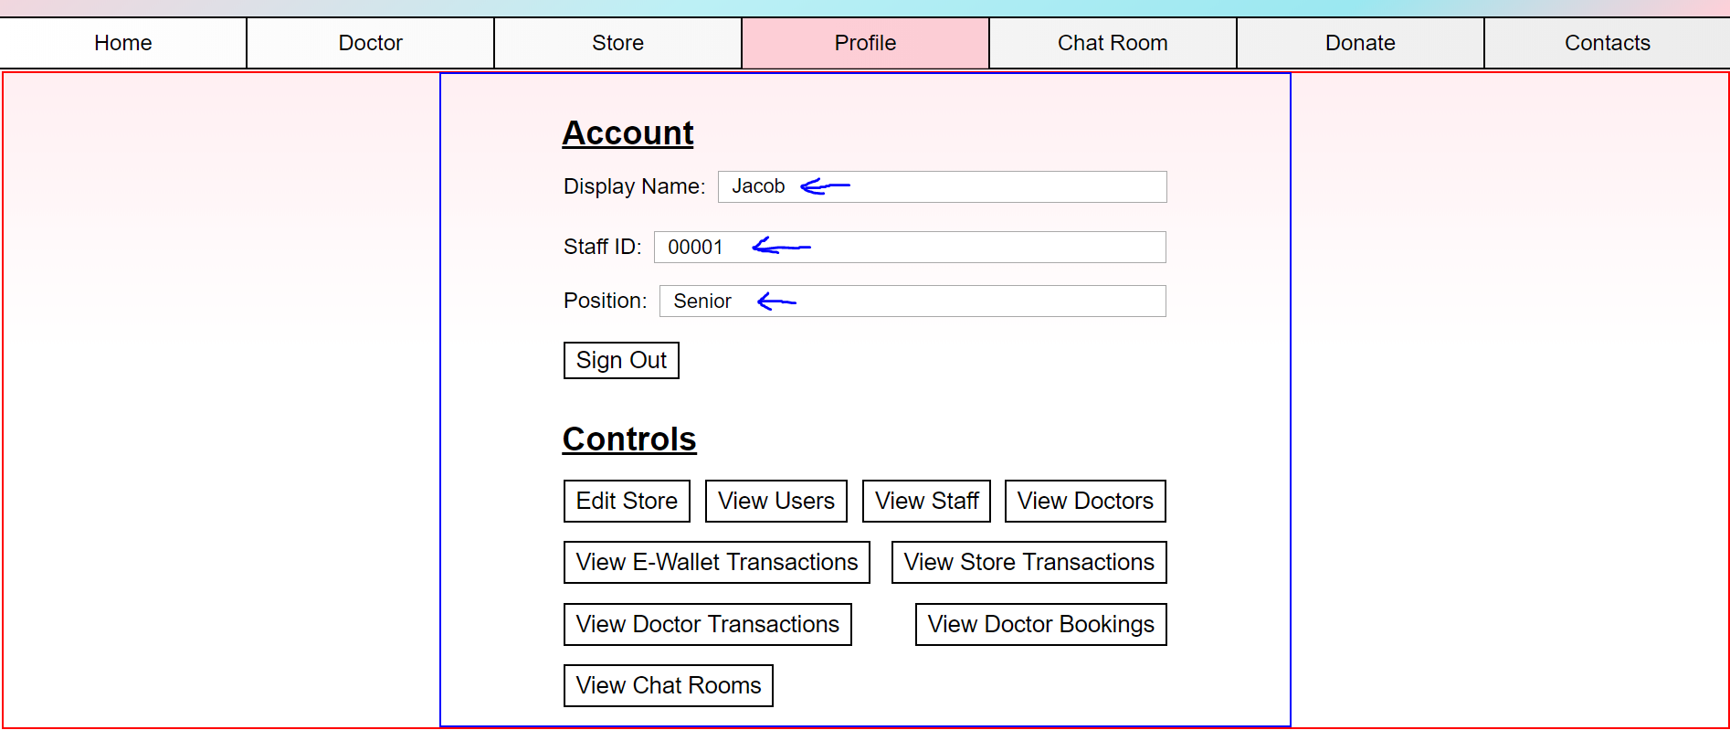

2.After logging in, the staff display name will appear with their staff ID and position. Positions include: Senior Position or Junior Position.

Senior Position can both edit/add and view data.

Junior Position can only view data.

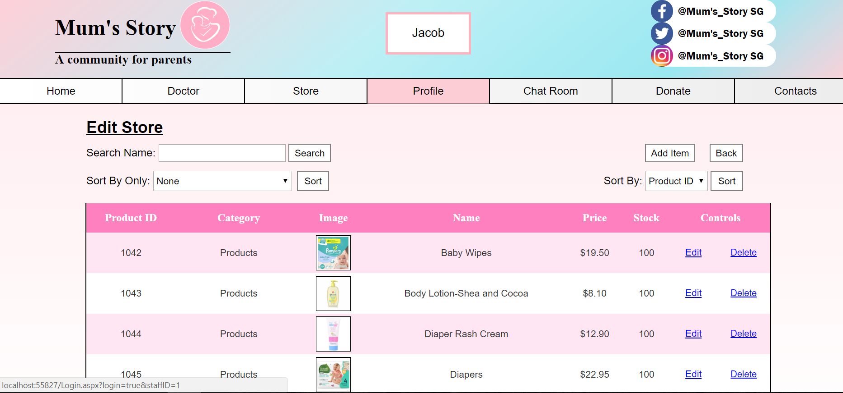

3. When the staff click on “Edit Store”, it will go to the Edit Store page.

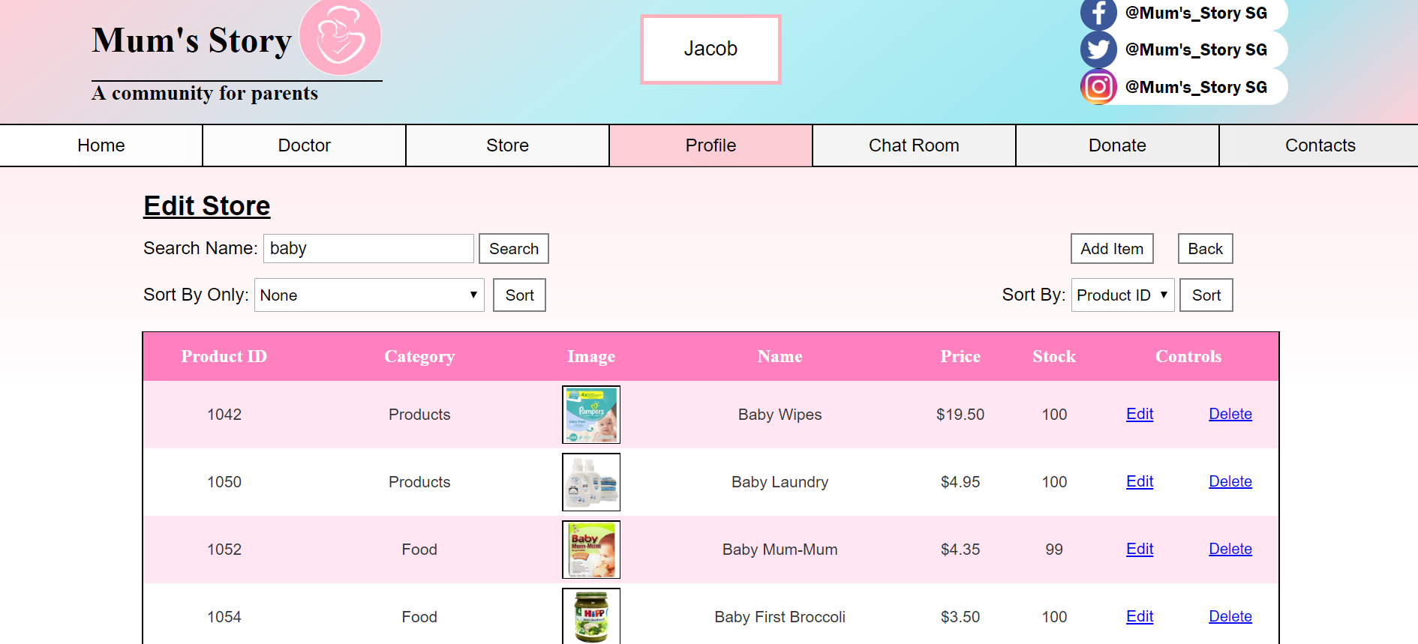

4. The Edit Store comes with a search bar and 2 sort bars.

For example, when the staff wants to edit products that has the keyword ‘baby’ , the list of related baby items will appear.

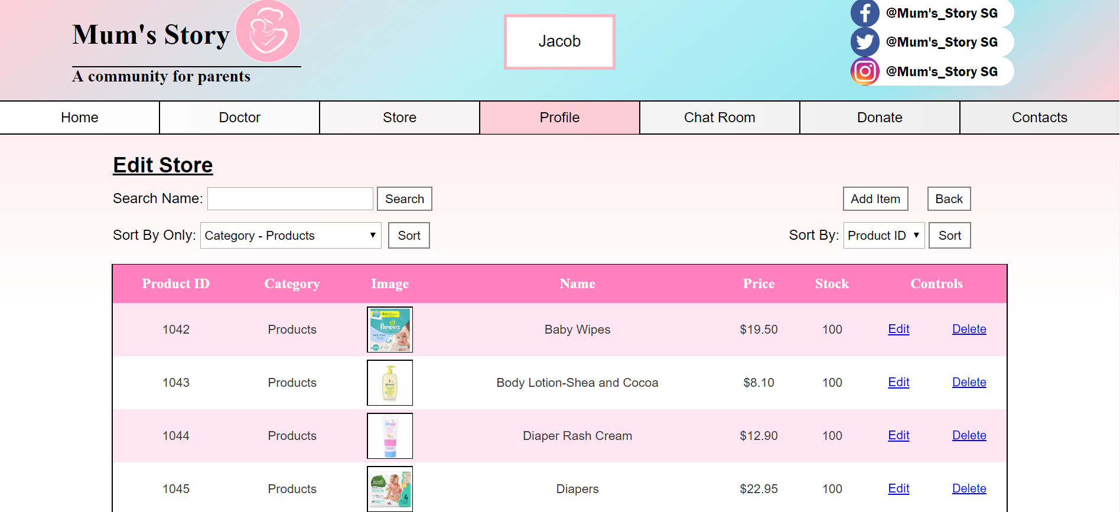

5. The “Sort By Only” filter items based on the category. For example, when the staff sort by “Food”, only food items appear.

The “Sort By” organises the items. Eg. Name.

Both sorting work together as well.



6. The staff can also edit and delete the product item.

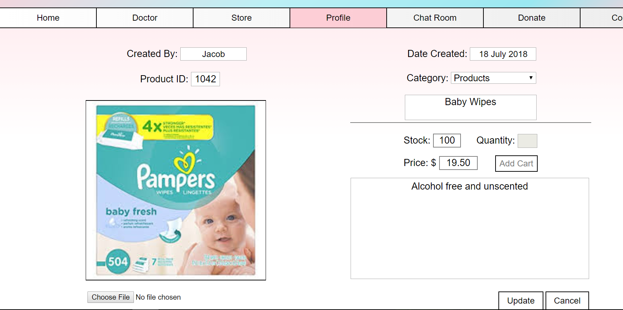

7.Upon clicking on the edit button, staff can edit the necessary information that they wish to change. After editing, the staff will have to click on the update button the particular product will be updated in the store page.



8. The staff can also click on the delete control.



9.If the staff were to delete the product from the gridview, the product will be deleted.

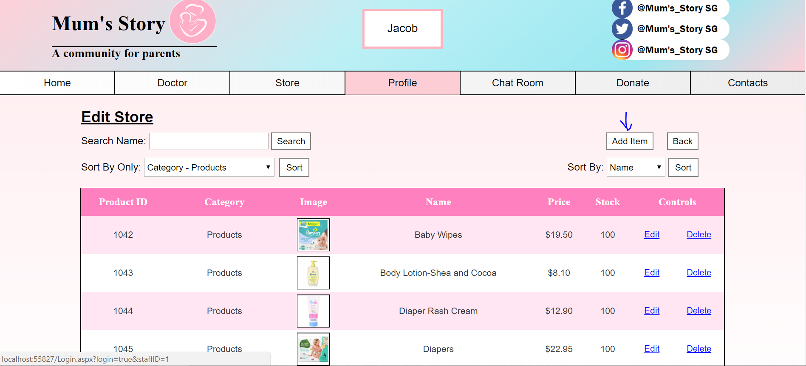

10.The staff can also add new product item by clicking on the add item button.

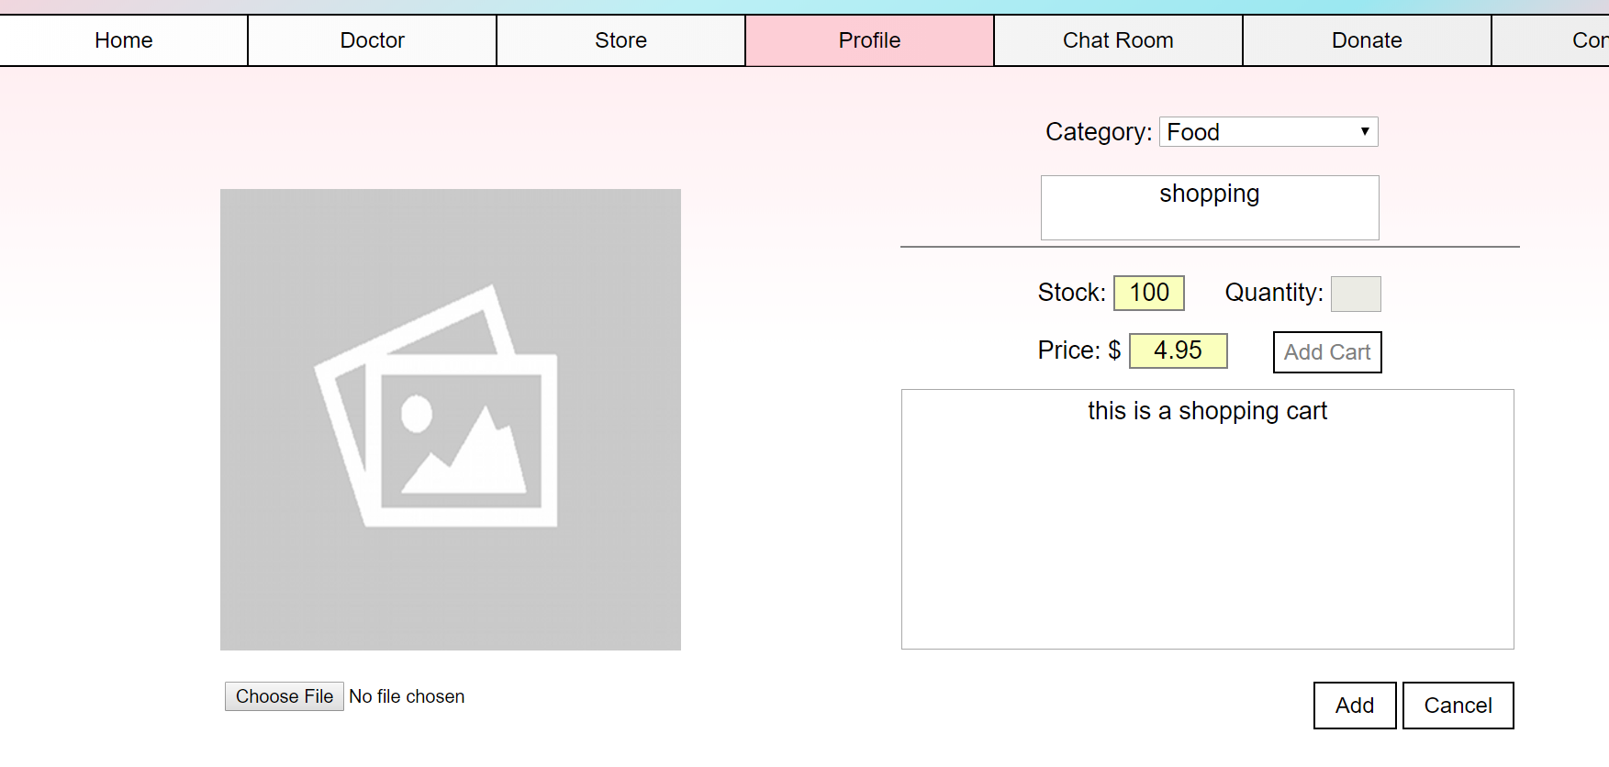

11.Upon clicking the add item page, it will link to this webpage where the staff can add images, the category of the item and the product description. However, they will not be to click on the ‘add cart’ button and also the quantity as it has been disabled for the staff .

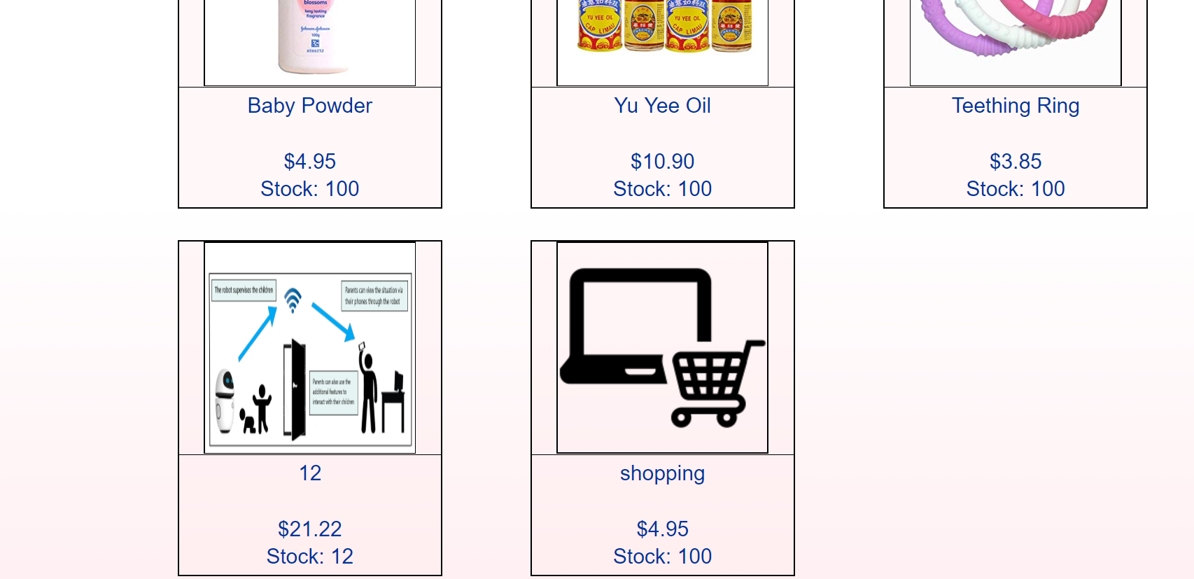

12.After adding the image , the newly added image will be added in the baby products category at the store page.

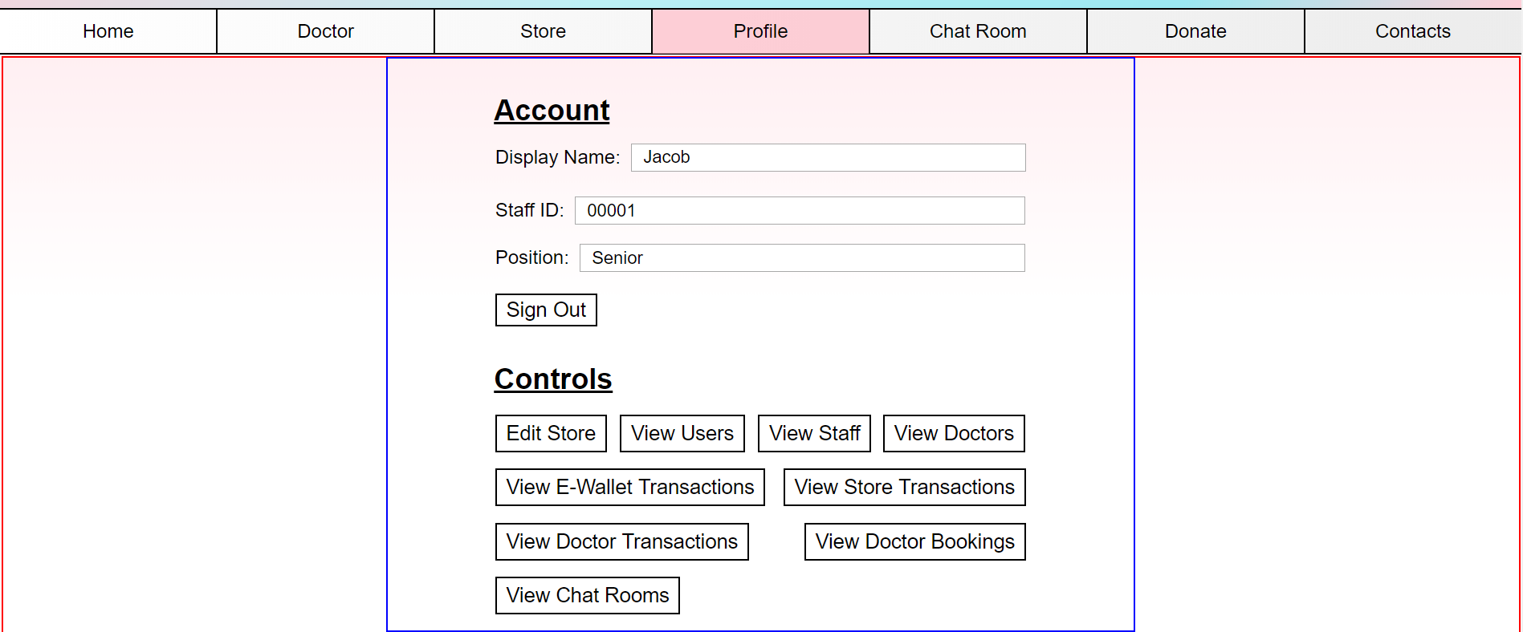

13.The staff can also view the user particulars when the click on the view users button.

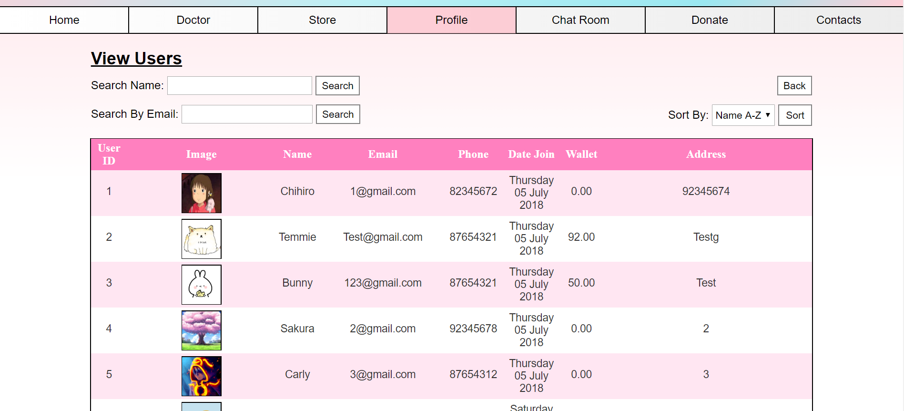

14.This is the the view user page where the staff can search for the user name and view the personal particulars of the user.

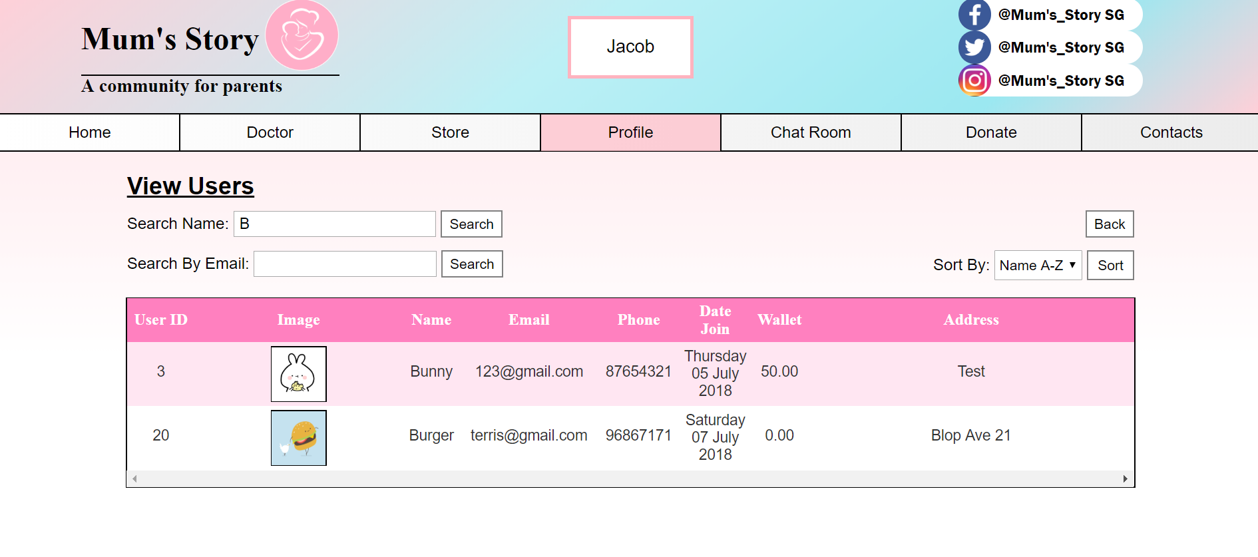

15.If the staff were to search for a particular user, the gridview will only show the user data related to the search.

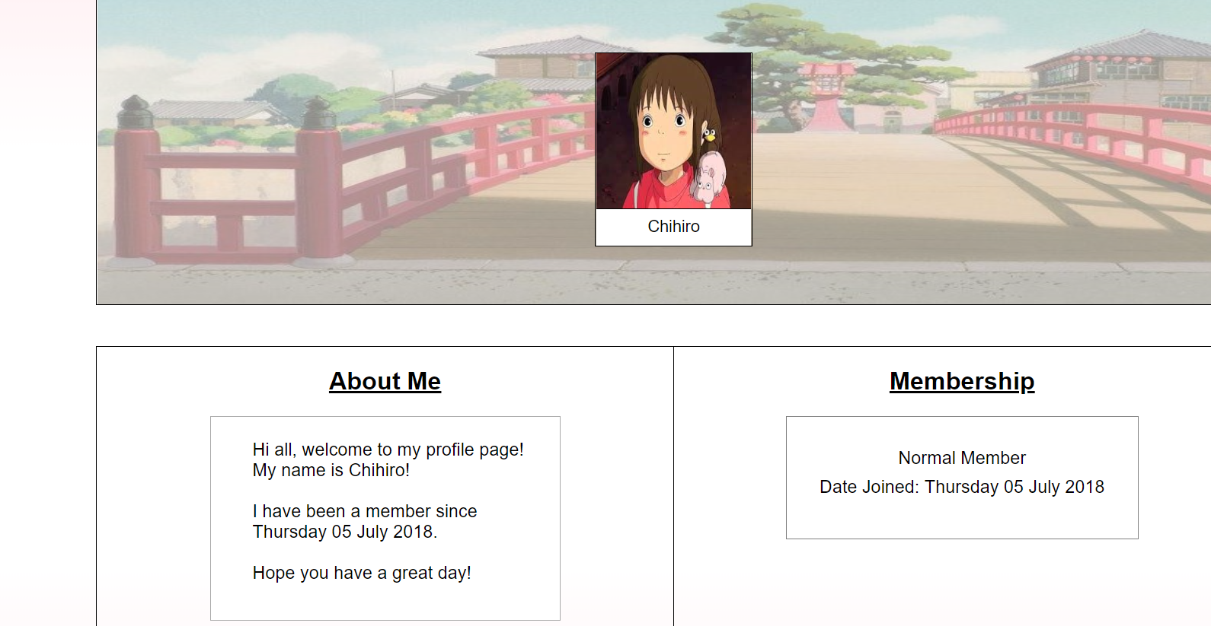

16. Upon clicking on one of the user particulars, it will go to the users profile page where it will show the particulars of the users.



17.The staff can also view the staff data in website.

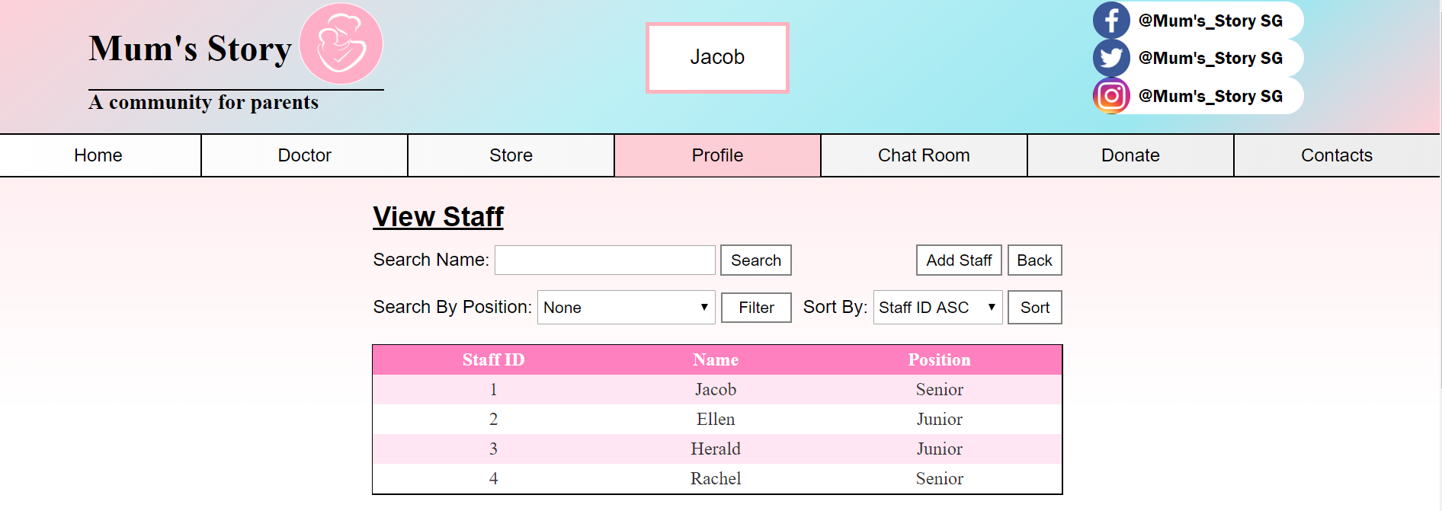

18.After clicking on the view staff, the staff can view the staff data in the page such as the position of the different staff and their user ID and name.

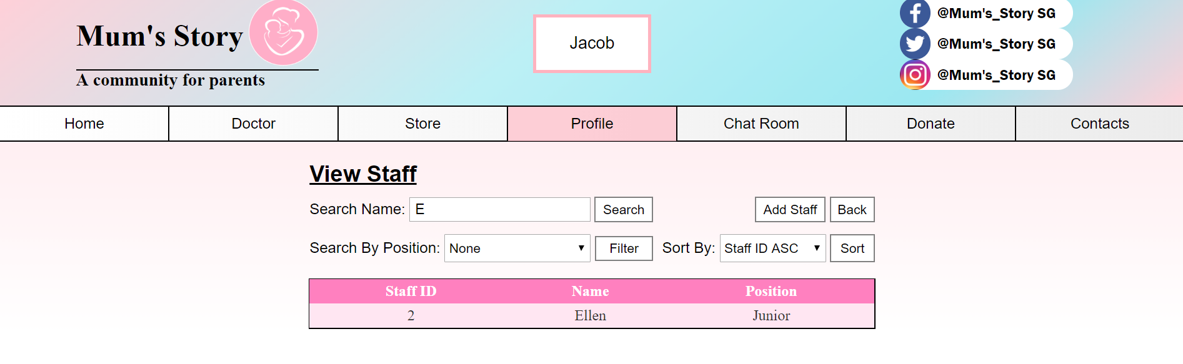

19.If the staff would wish to search for a particular staff, they can just use the search bar to find the particular staff information. In the view staff page, the staff are able to add staff as the user position is senior, hence, they are able to add new stuff into the view staff page.

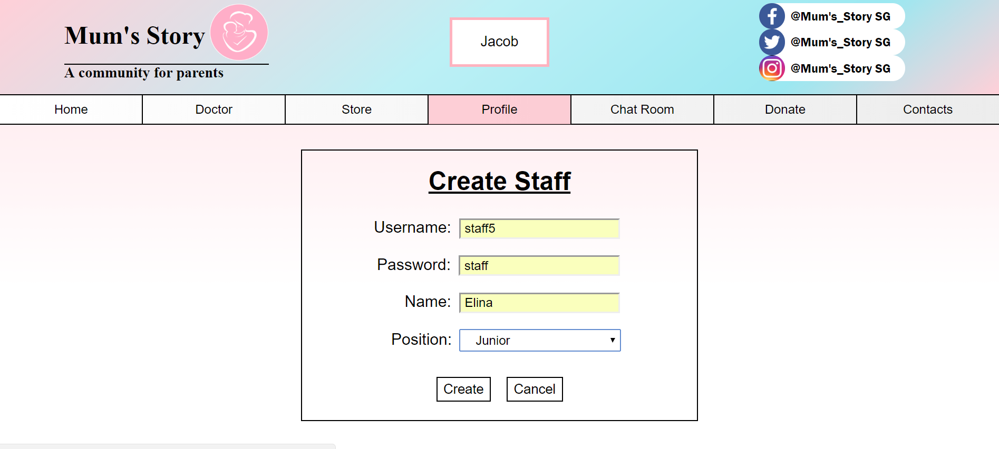

20.Upon clicking on the add staff, it will be link to the create staff page where the senior staff can create username and password for the senior and junior staff.

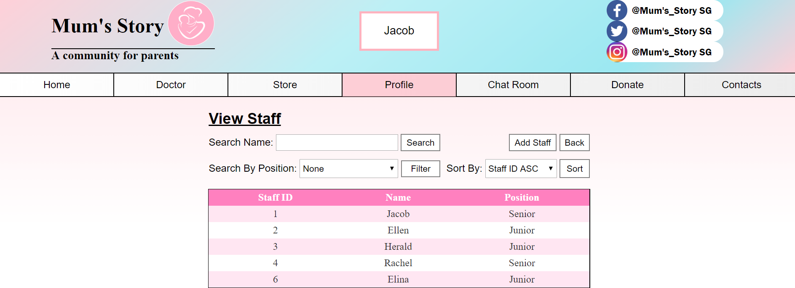

21. After creating the new user, the new user will reflect on the view staff page.

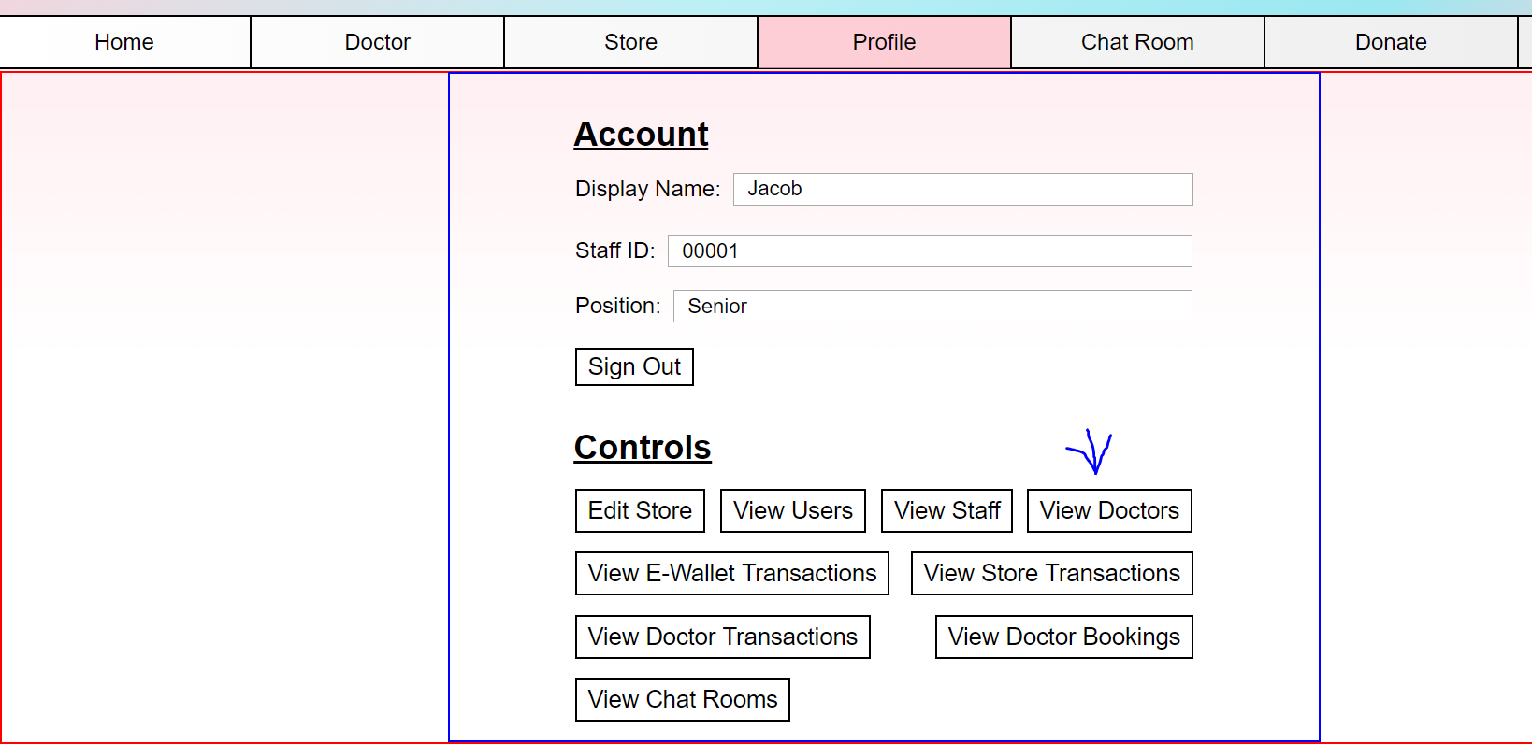

22. The staff can also view the doctors page through their profile page.

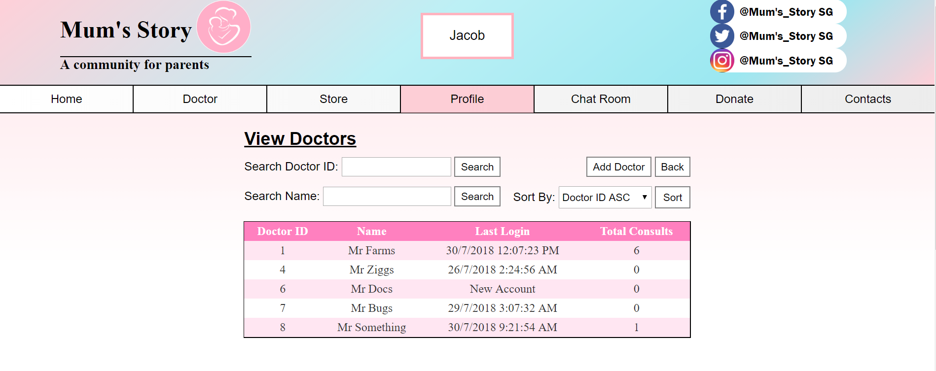

23. In the view doctors, staff can search for the doctor's name and other doctors particulars. The last login and total consult is important as it ensures that the doctor is doing their job properly .

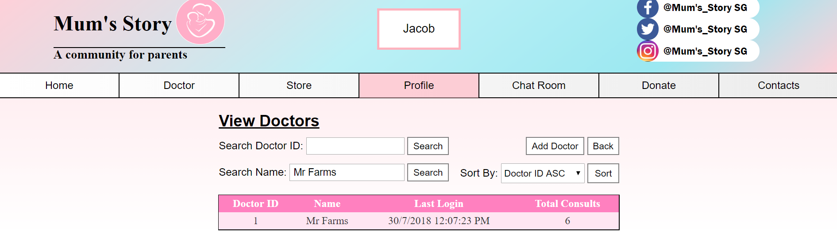

24. The senior staff can add doctor

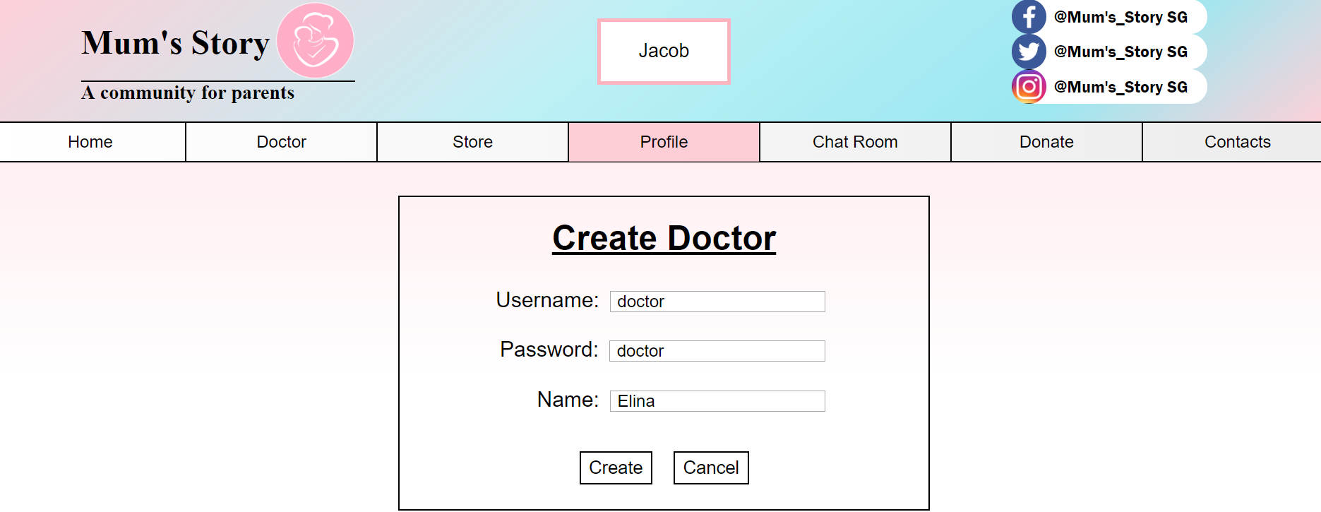

25. The senior staff can create the doctor username and password.

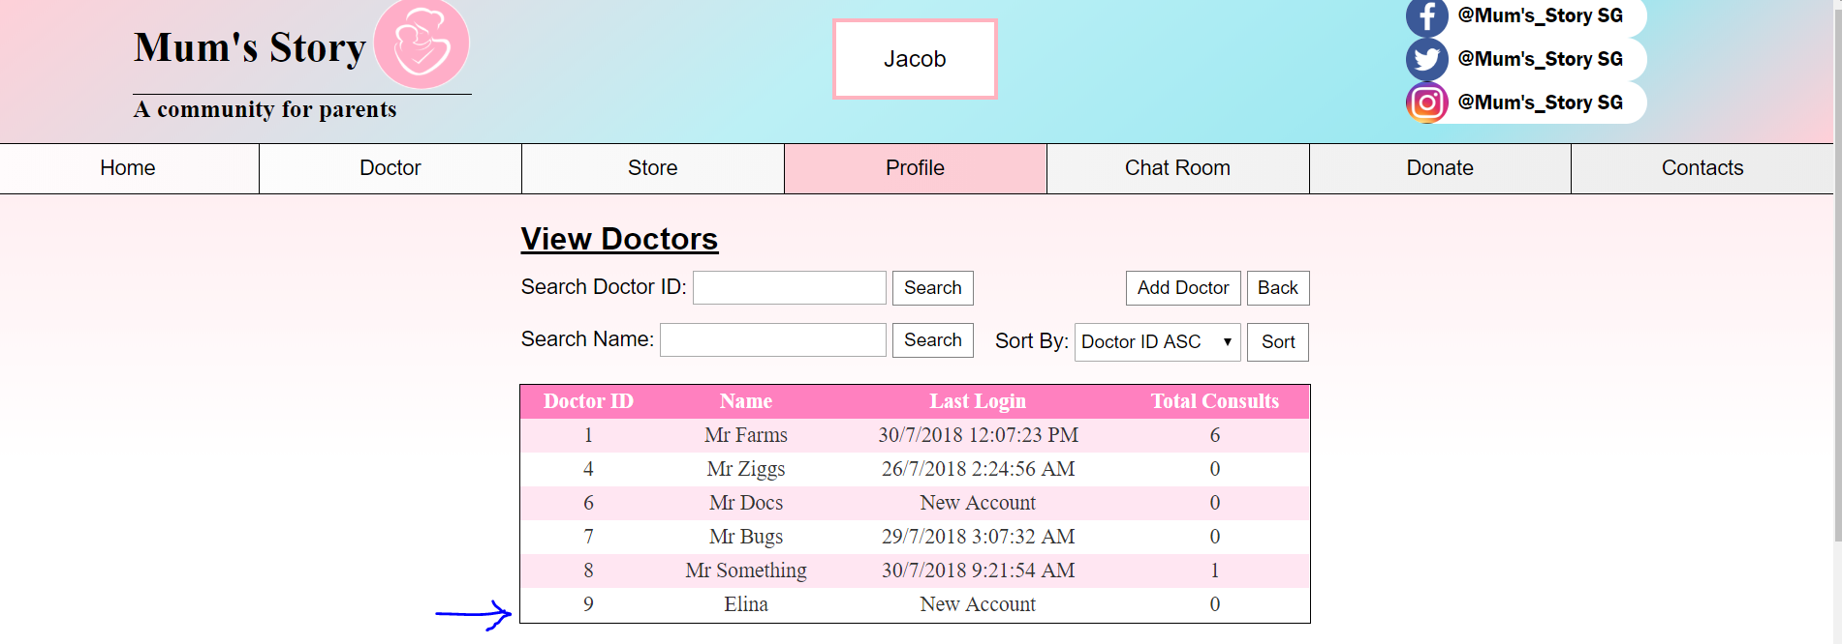

26. The new user is being added to the view doctors.

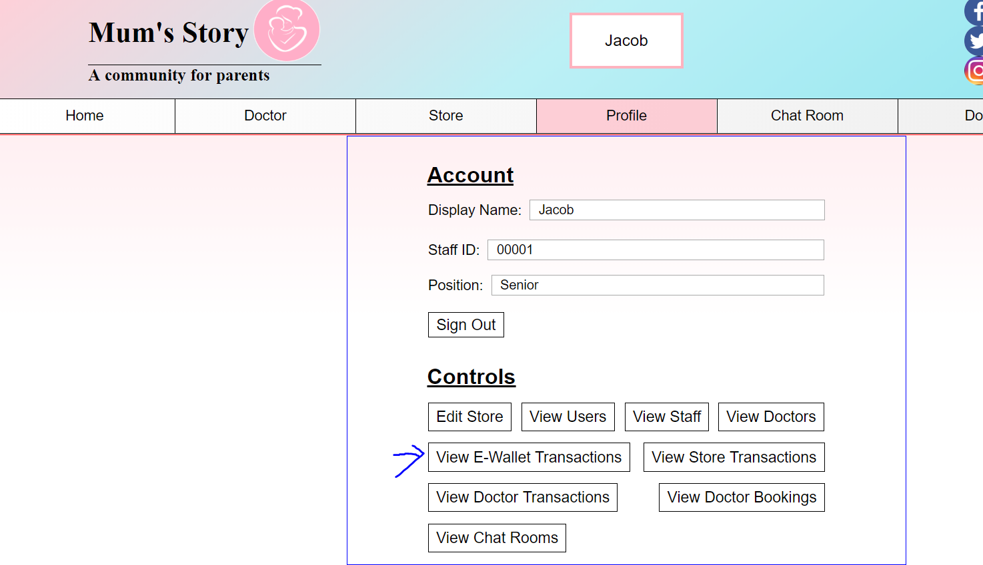

27. The staff can also view the e-wallet transactions for the different users.

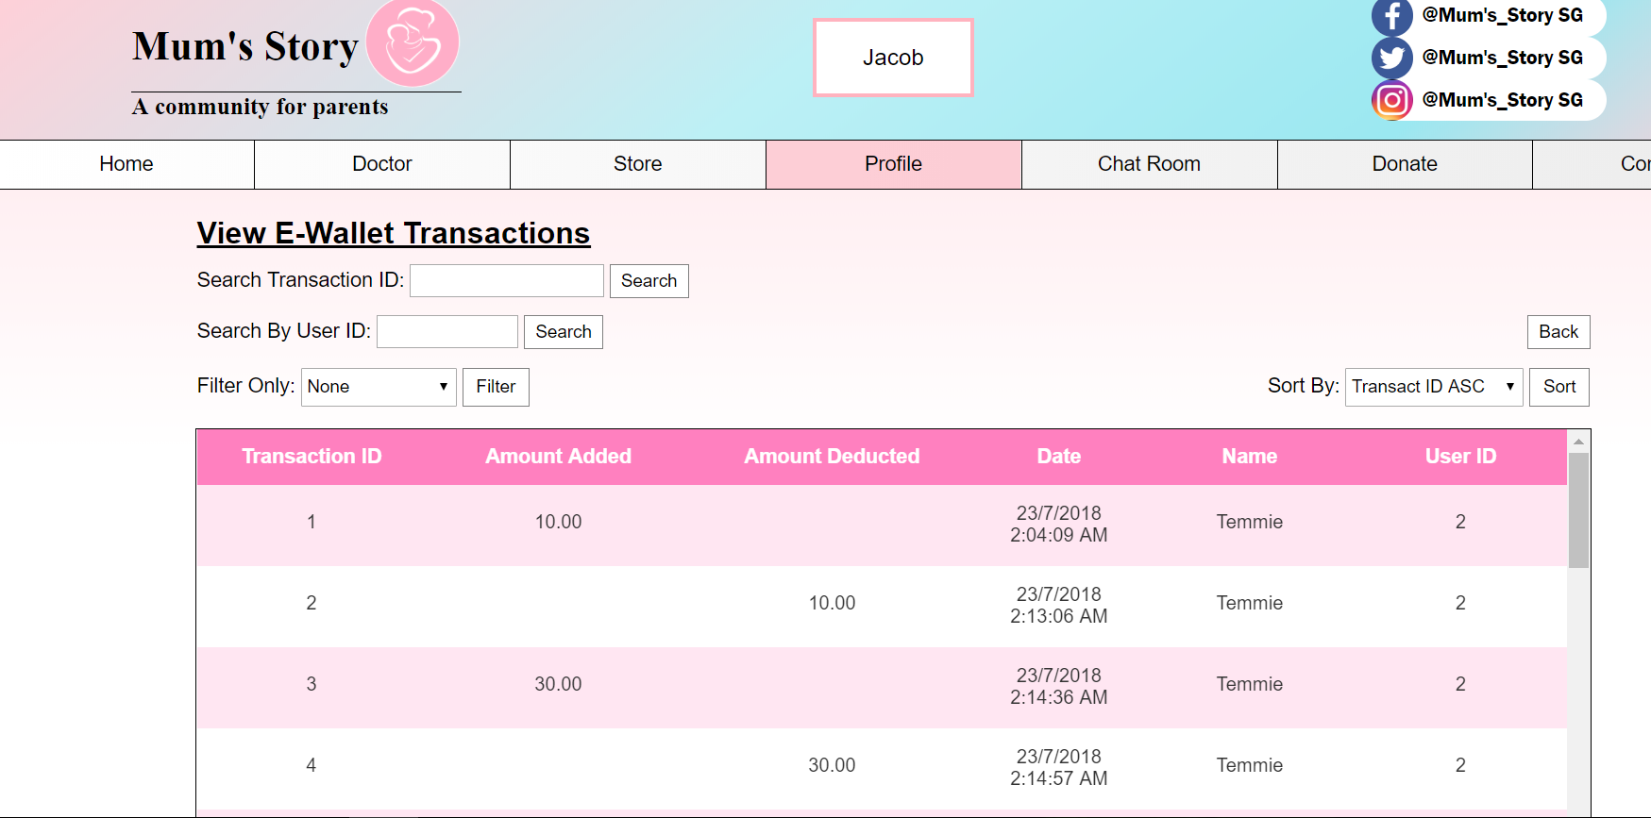

28. In the view ewallet transaction, staffs can view the users ewallet transaction with the amount they they add and deduct from their ewallet. In addition the staffs can also filter by the amount added and also amount added.

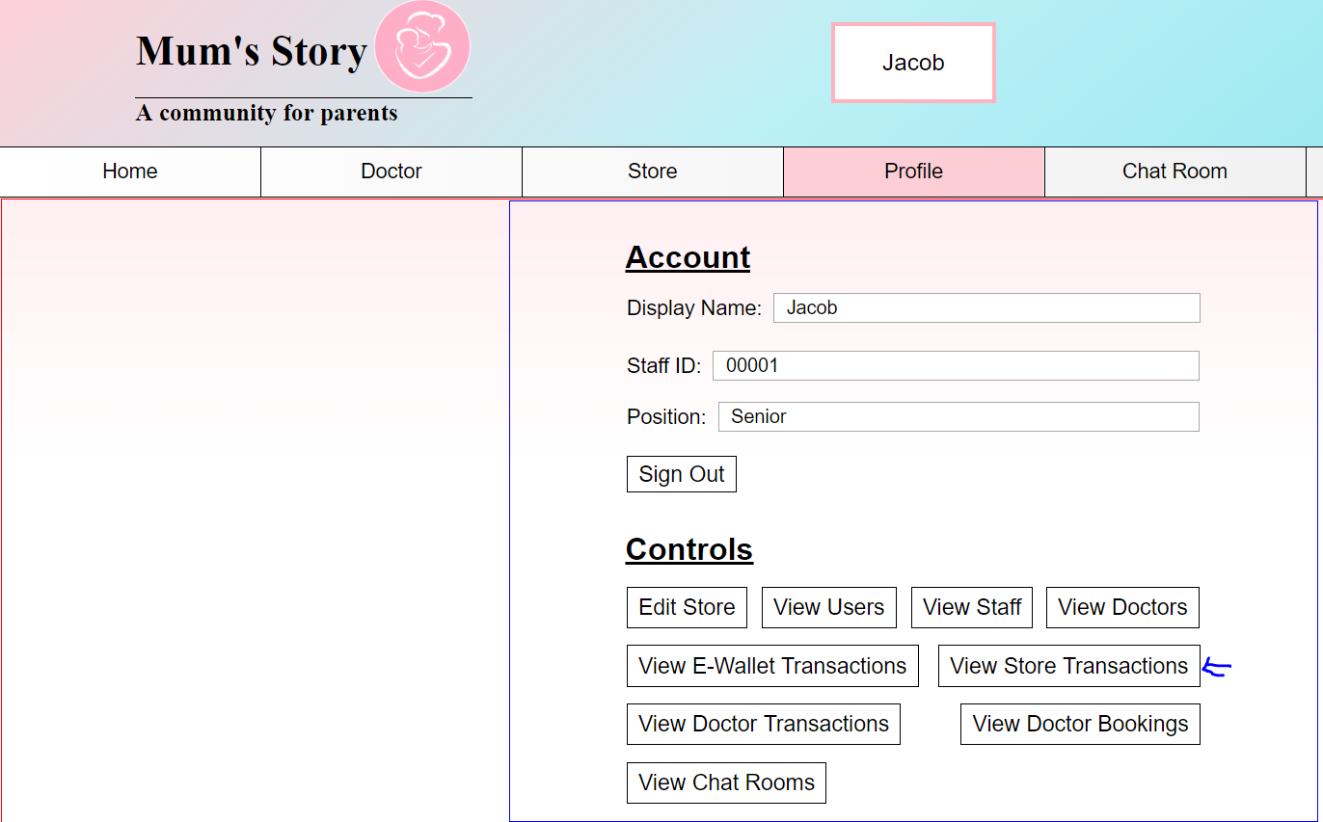

29.The staff can also view the store transaction.

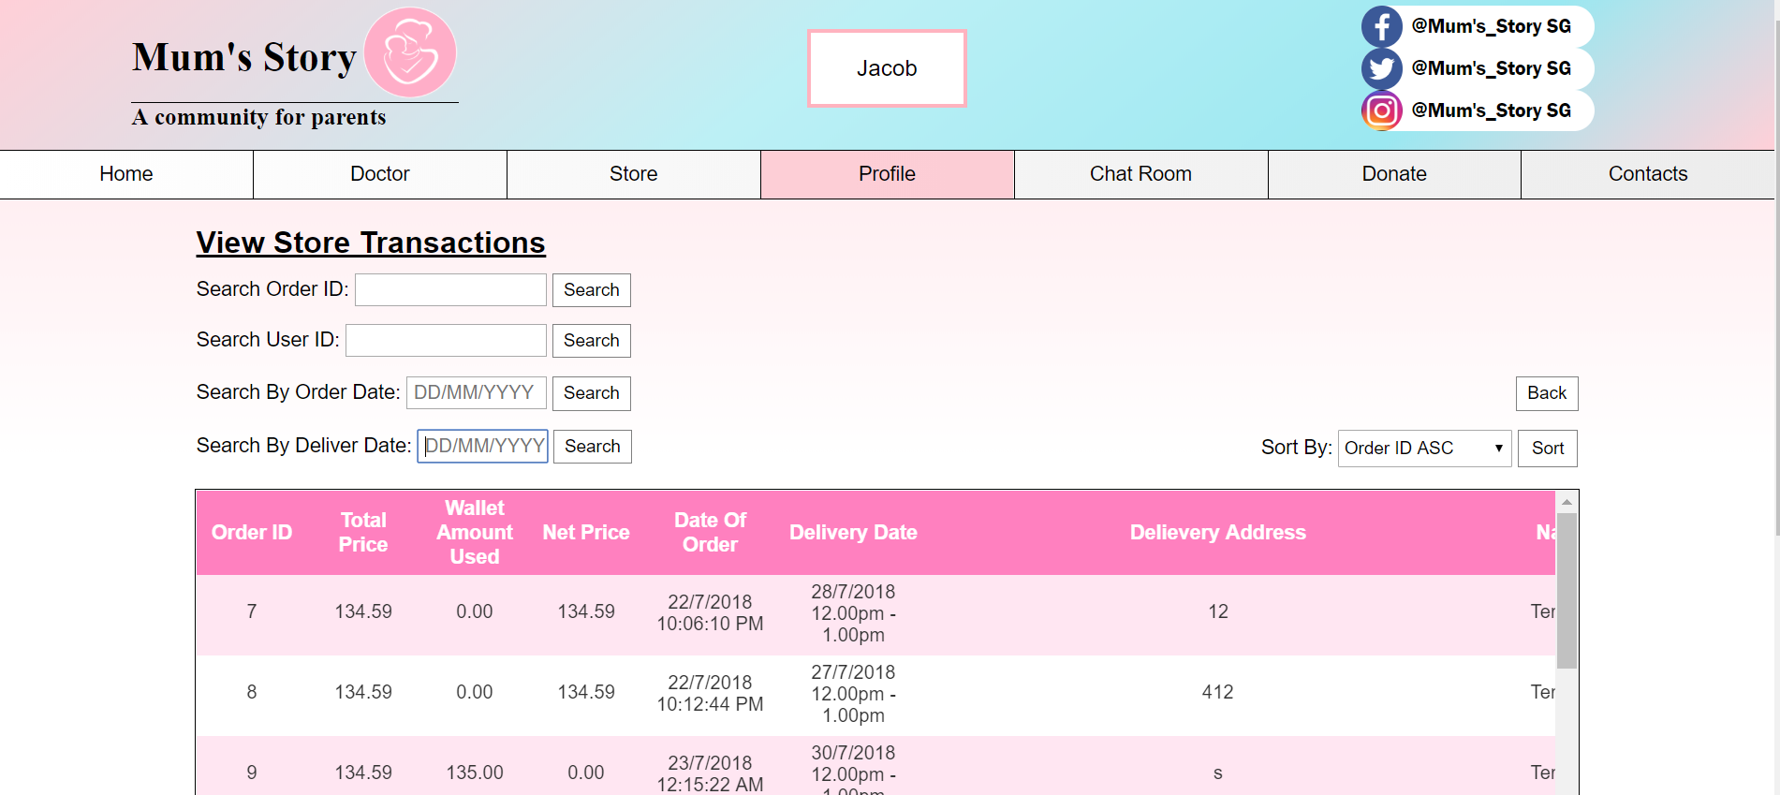

30. The view transaction will show the order details and the net price from the users store transaction. The staff can also search on the delivery date on when will the goods are being delivered to the customer.

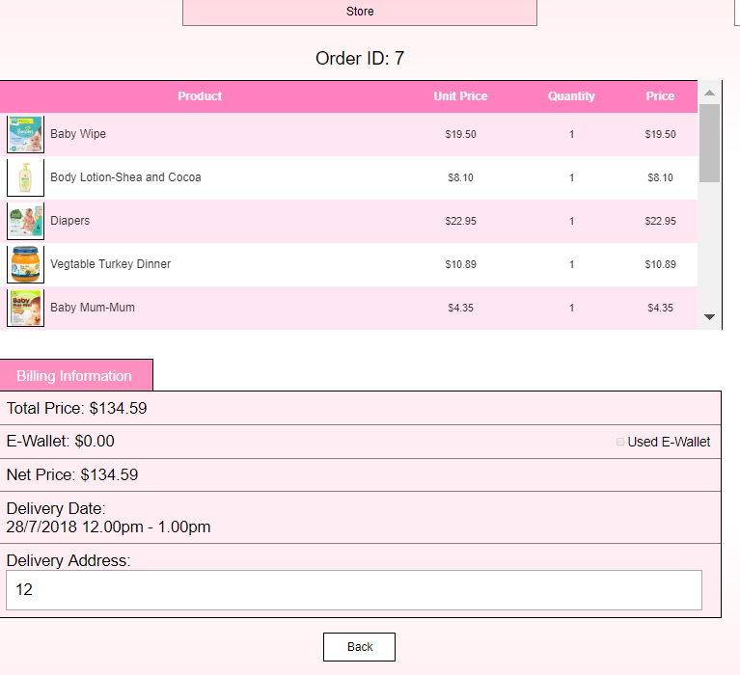

31. Upon clicking on the order details, It will link to this page where it will show product receipt from the users purchase with their given order ID.

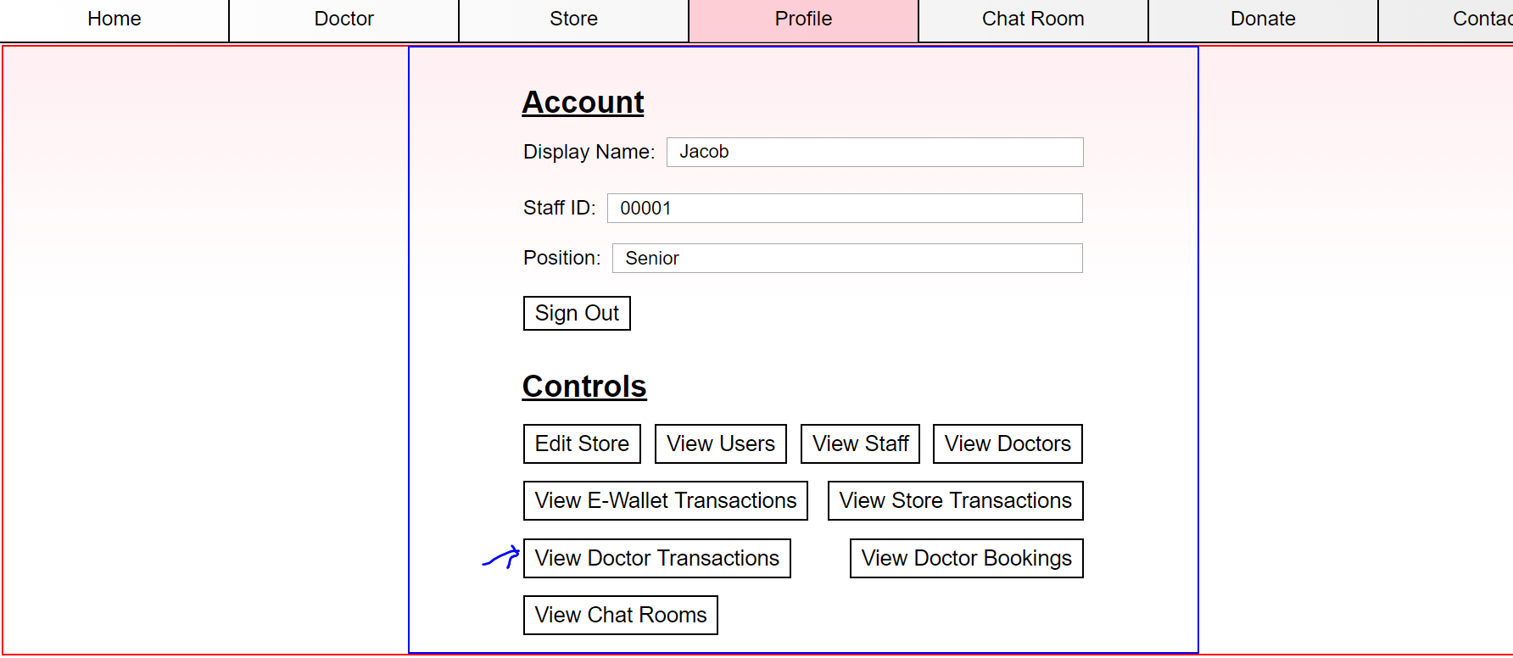

32. The view doctor transaction will show the doctor status and the consultation progress with the customer.

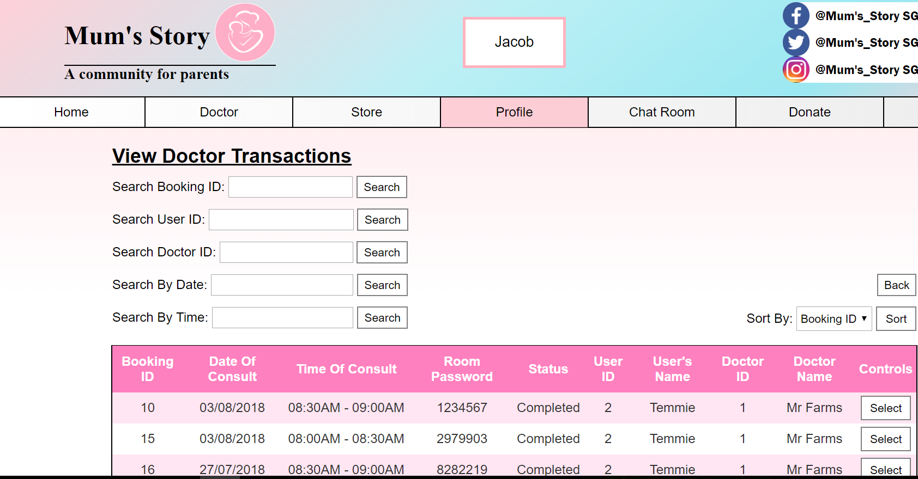

33. This will show the doctor transaction with the user and the consultation details. The staff can also check on the time of the consultation with the users and doctors.

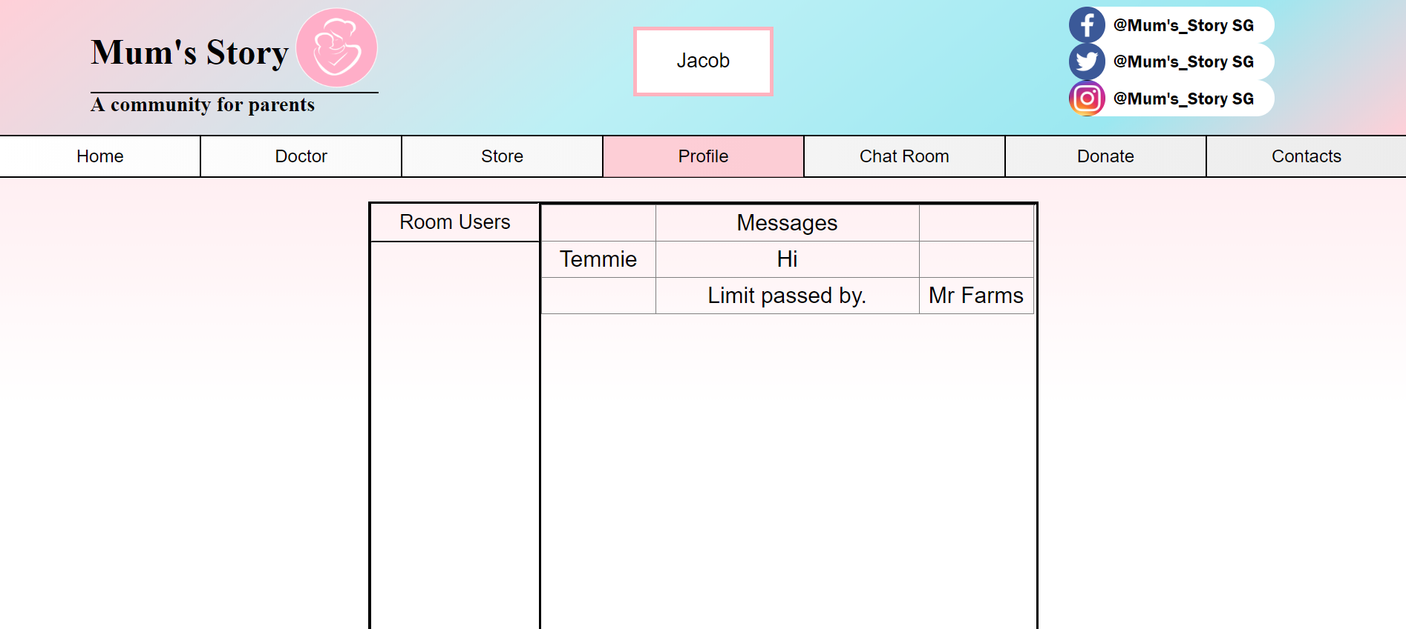

34. Upon clicking the select button, the staff will able to view the conversation between the users and the staff so as to ensure that the doctor is doing the job properly.

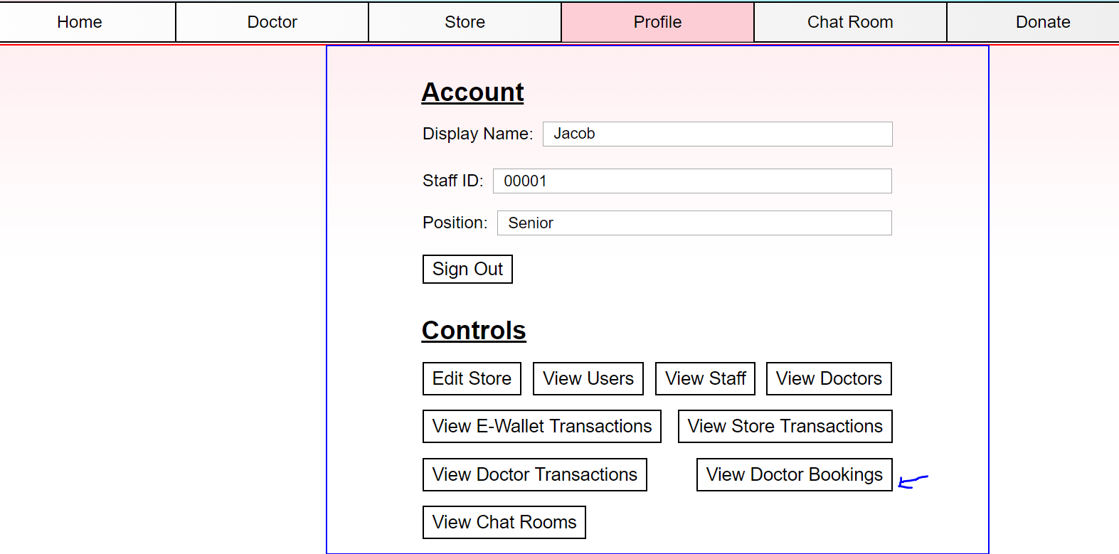

35. The view doctor booking will allow staffs to find the consultation information pertaining to the user and doctor information.

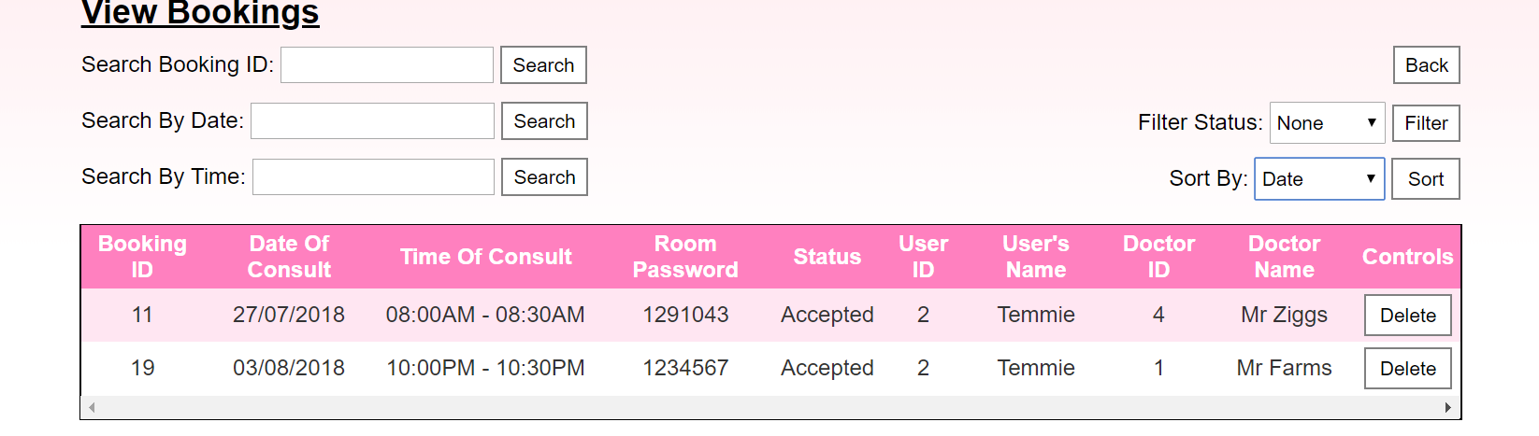

36. The staffs will be able to view the doctor and staff consultation details and they are able to sort the date of the consultation to find the list of the consultation date and time of the consultation. In addition senior staffs can also delete the view booking if the booking has already pass the due date of the consultation.

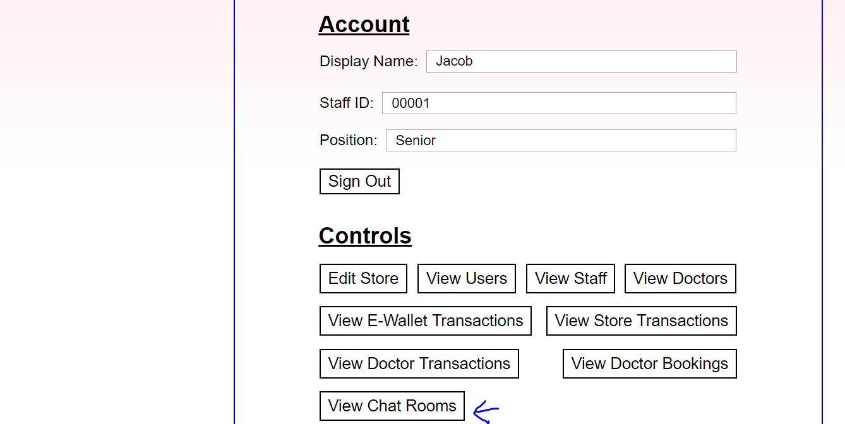

37. The staffs can also view the chatroom between the doctor and the users.

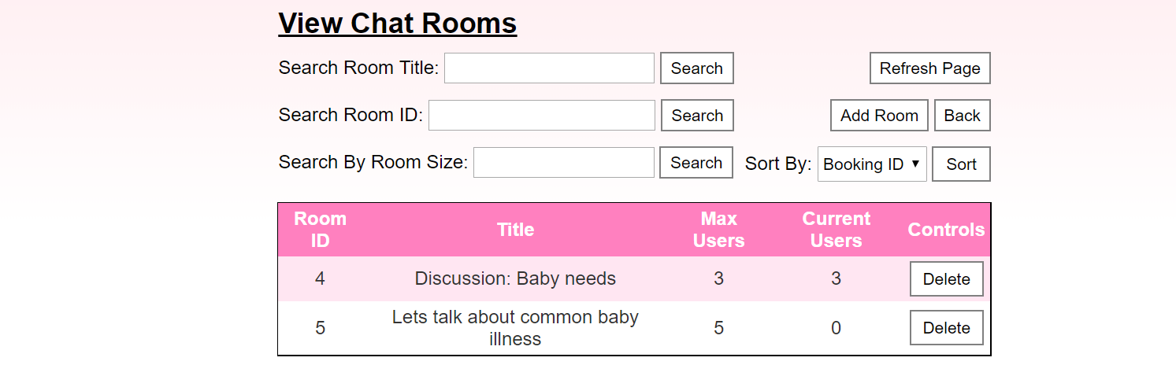

38. At this page, the staff is able to view all the created group chat rooms and the number of people currently in the room and the maximum users allowed in each room.

The senior staff will then have the right to delete any chat room that does not have any users in the chat room or when the chat room is not in use anymore, by pressing the delete button.

### **User**

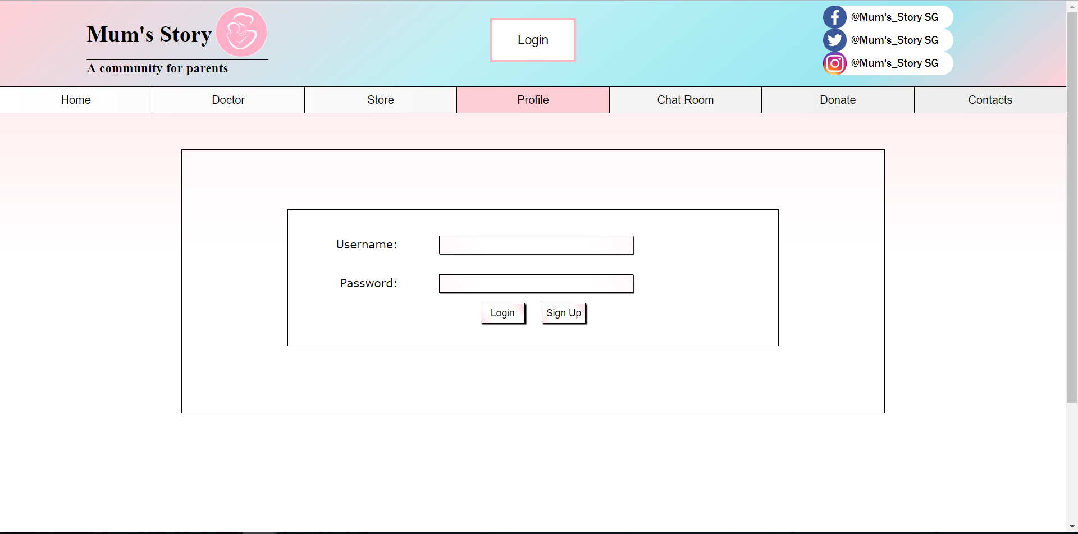

For users, they first have to sign up by clicking the ‘Profile’ button then the ‘Sign Up’ button.

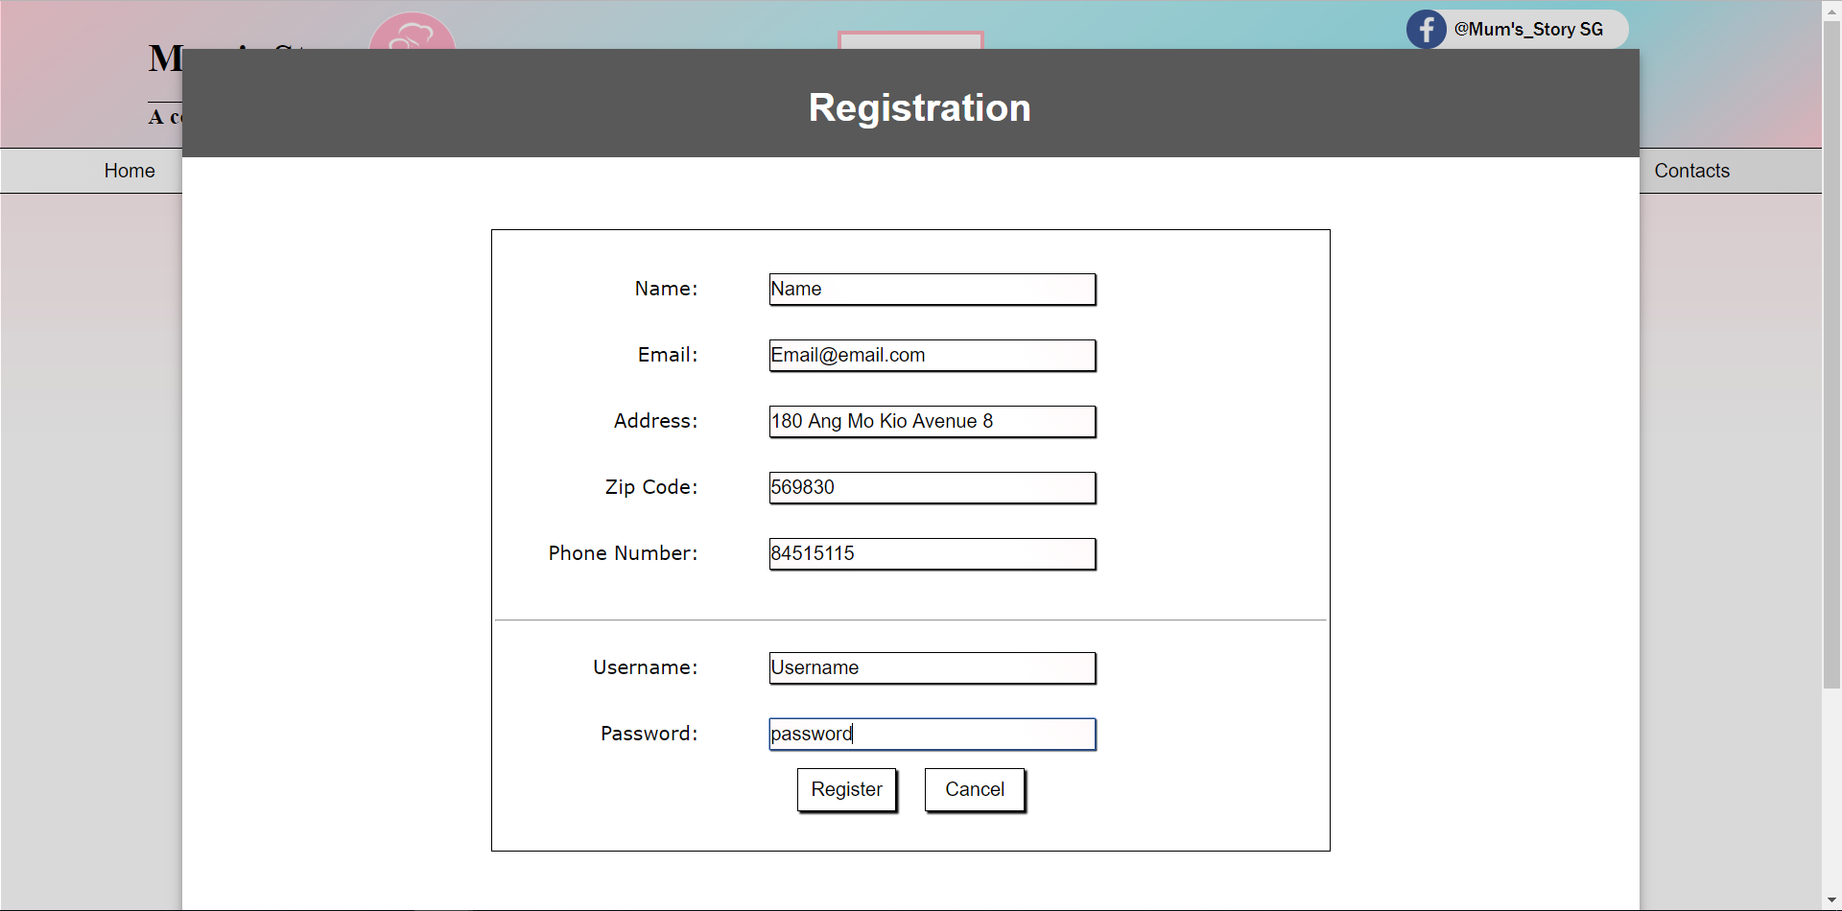

A registration window will pop-up where users have to fill up their personal information.

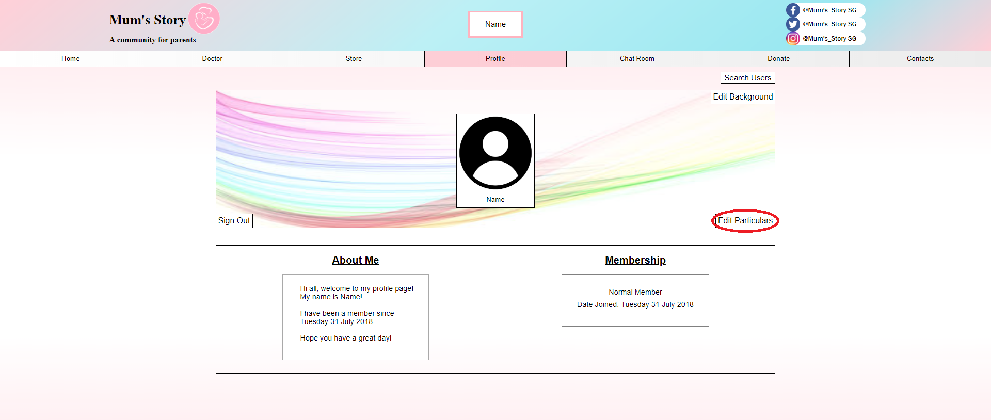

After a successful registration, the user will be logged in and led to the profile page.

For a smooth experience, users will have to click on ‘Edit Particulars’ to top-up their e-wallet.

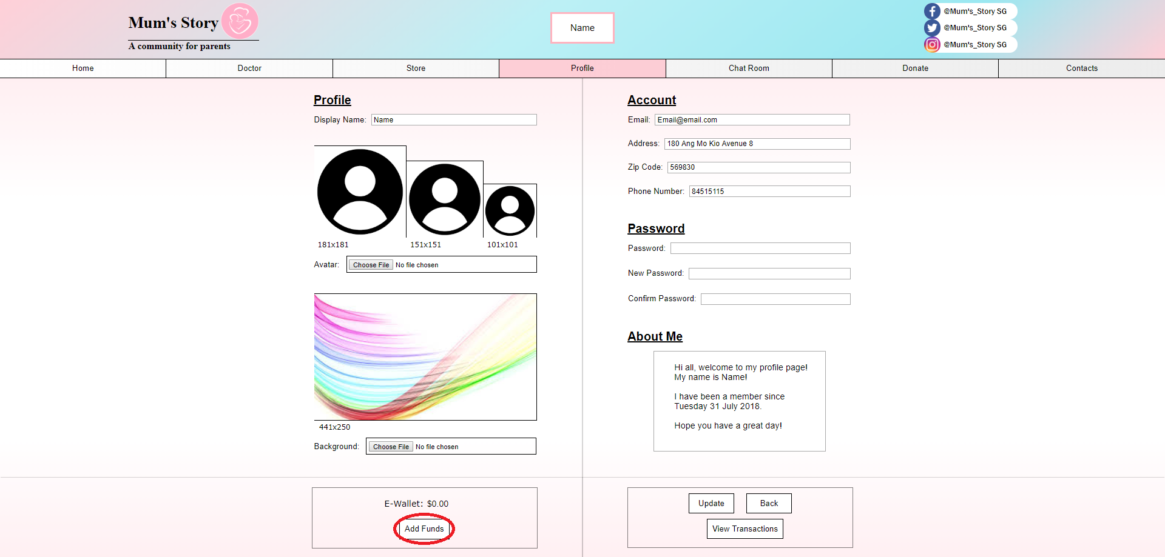

Click on the ‘Add Funds’ button. Take note that the E-Wallet is currently holding $0.00



Users will have to re-login for verification purposes.

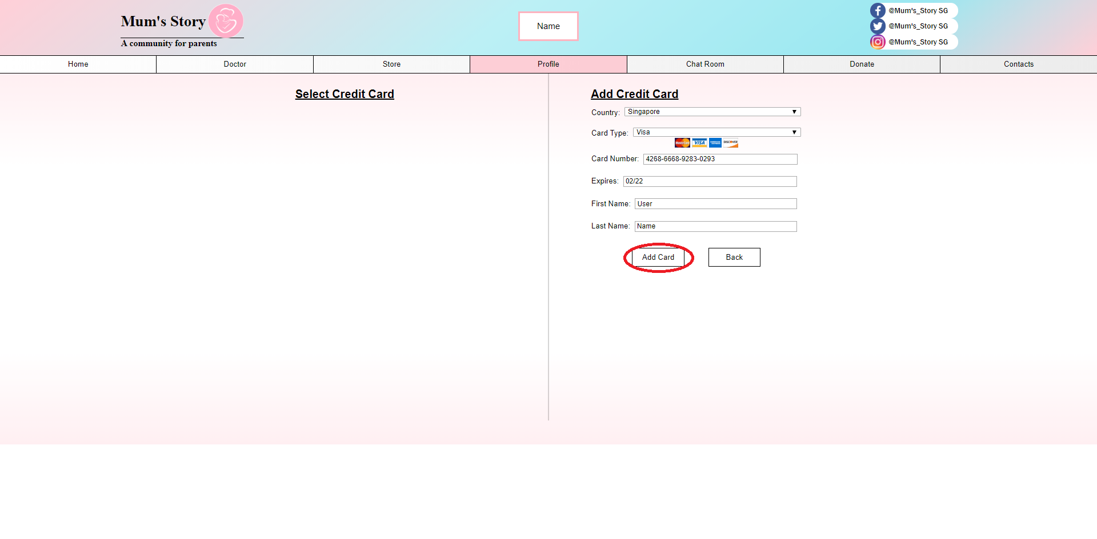

Afterwards, users have to fill-in their credit card details.

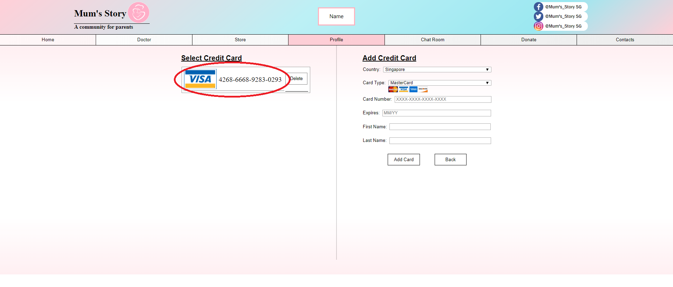

If card verification is successful, the card will appear on the left side on the screen. Users have to click on the card number to add funds into their e-wallet.

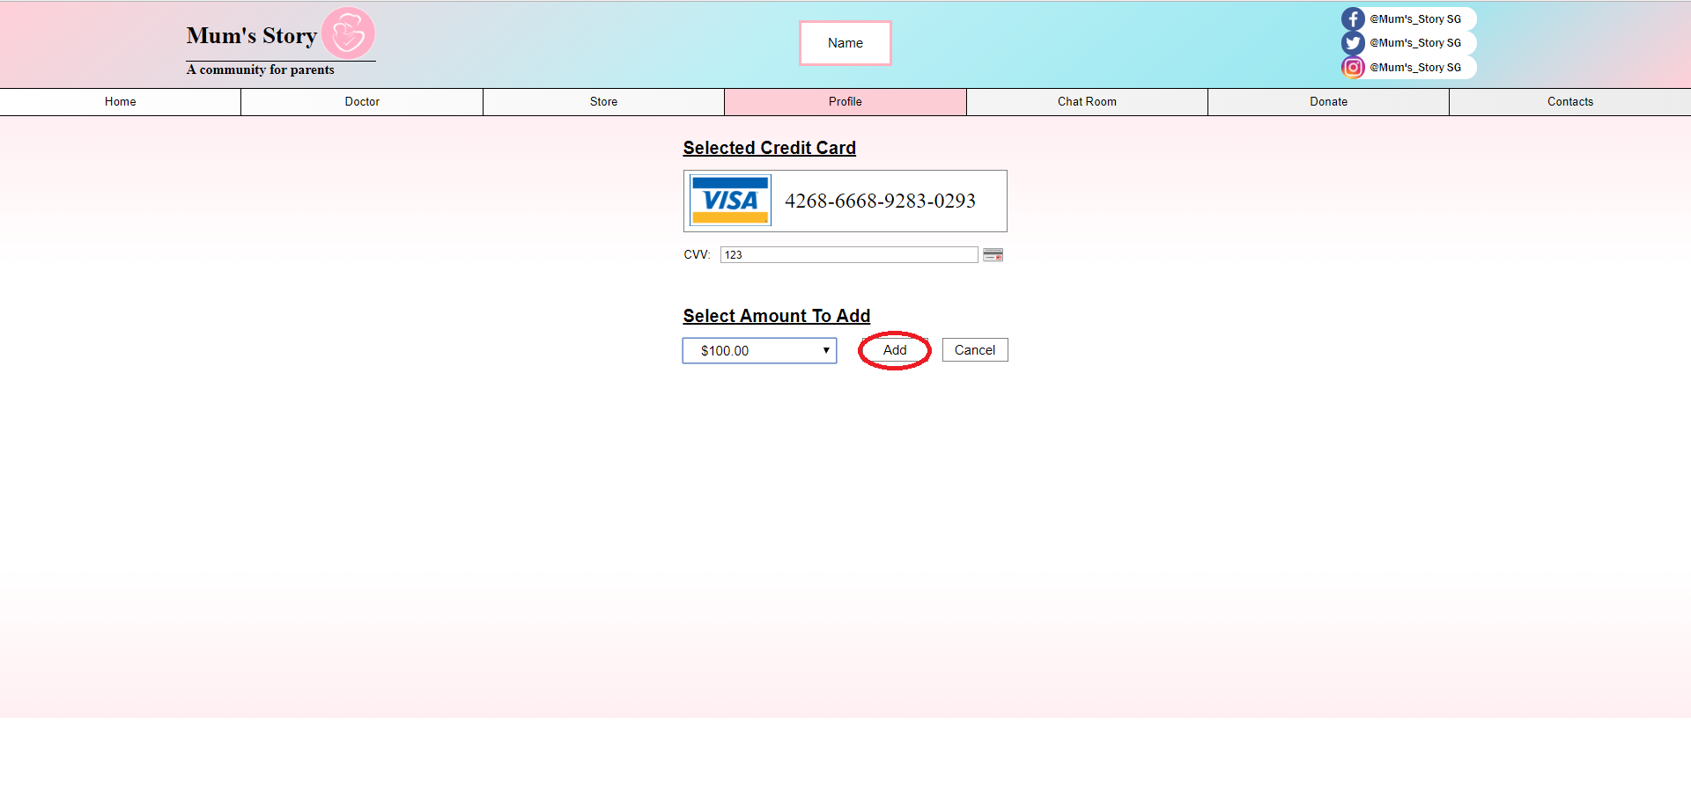

Users have to enter their credit card CVV and select the amount the wish to deposit into their wallet.

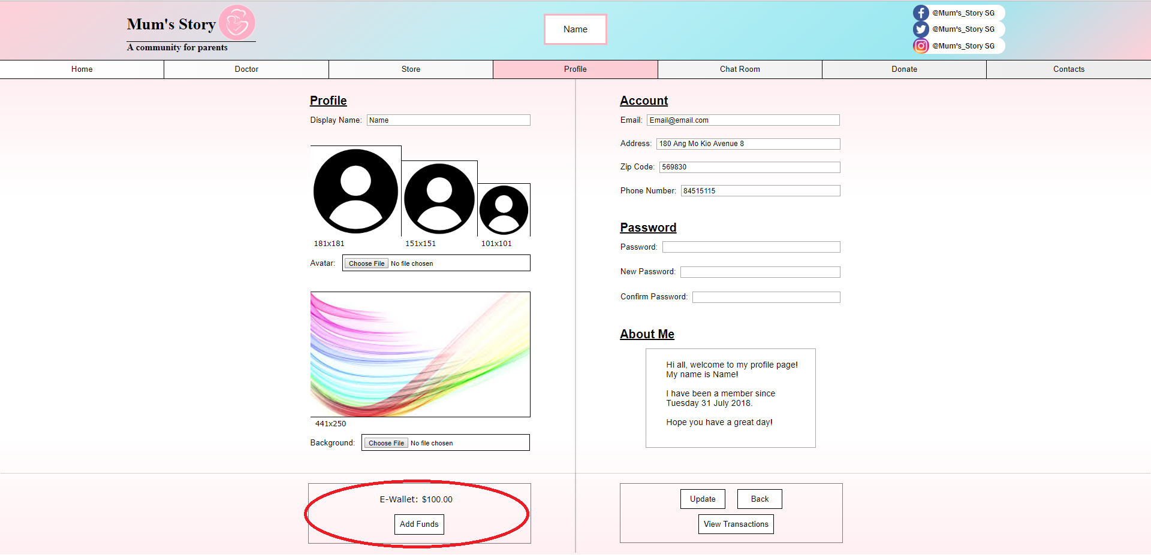

The amount in the E-Wallet is now $100.00.

**Online Doctor**

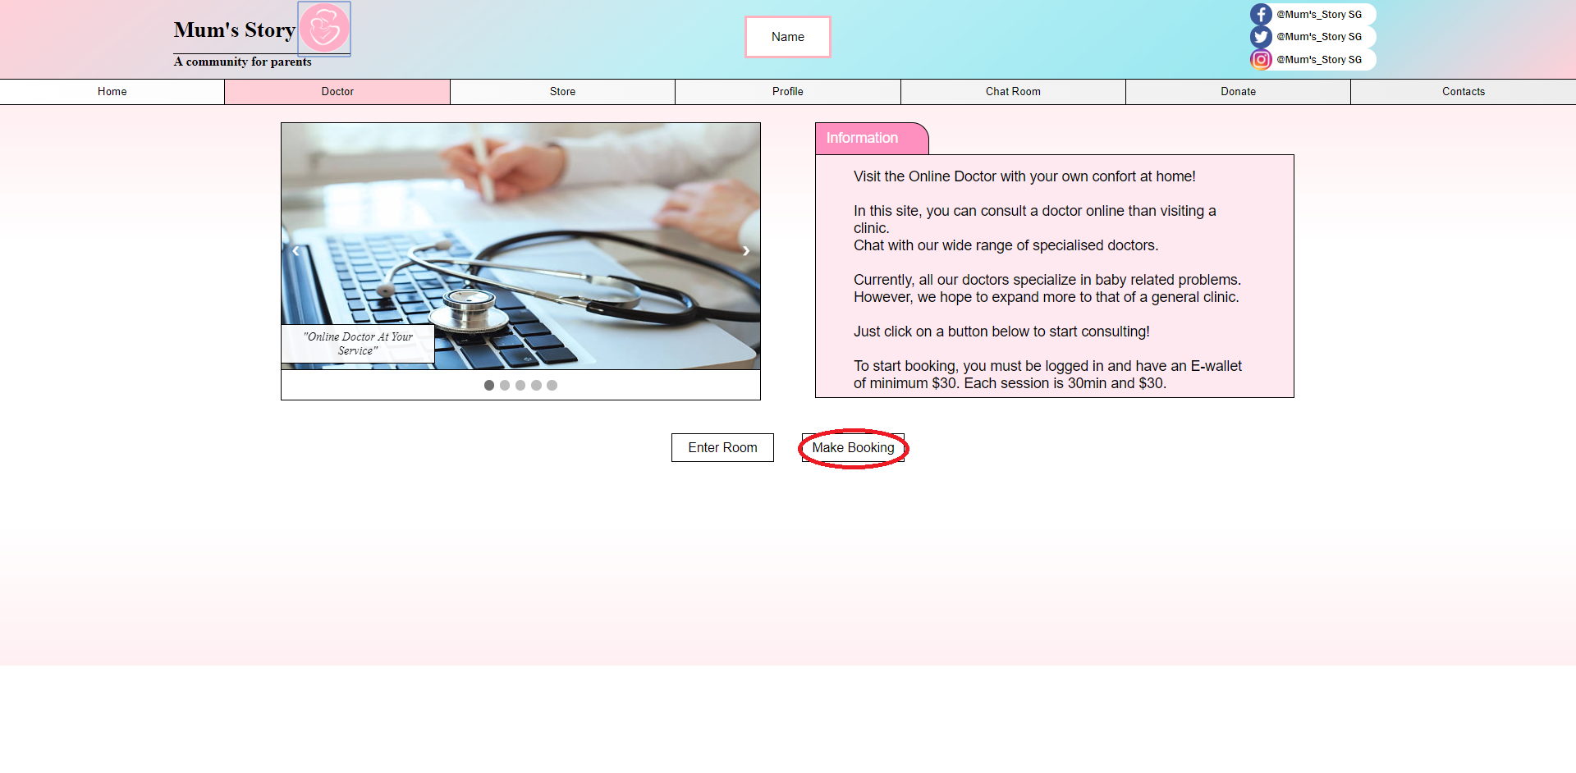

Once the funds are added, users can now visit the Online Doctor page to create a booking. Take note that the E-Wallet is required to contain a minimum sum of $30 to book a session. Click on the ‘Make Booking’ button to create a booking.

The web page displays the amount a bookings available. Users have to select either one of the bookings based on the availability.

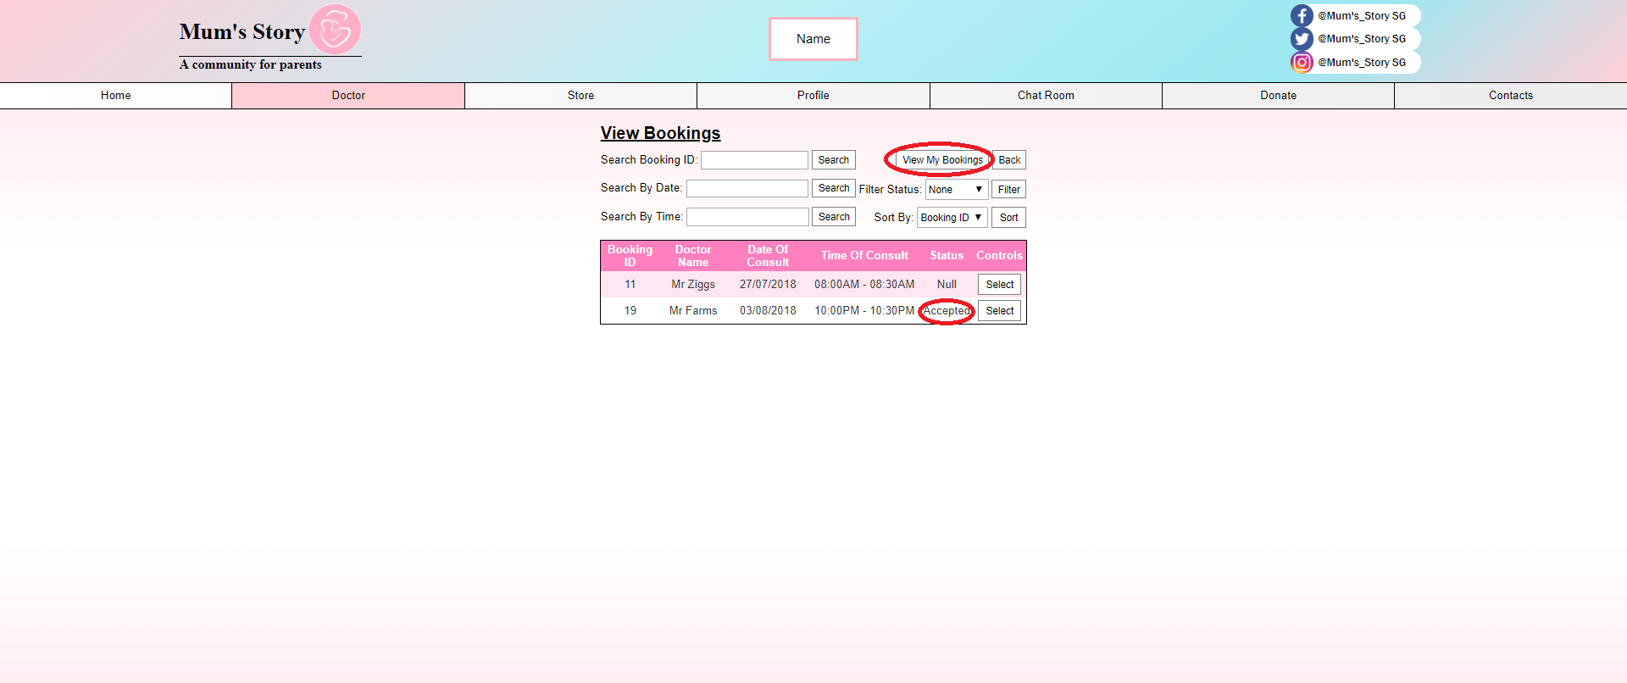

Once the user has selected the booking, ensure that the booking status has been changed from ‘Null’ to ‘Accepted’. Afterwards, click ‘View My Bookings’ to proceed.

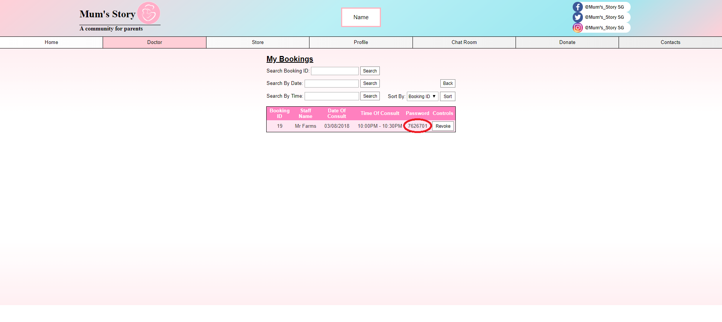

A password will be given for the booking ID. This password will be required to start the session.

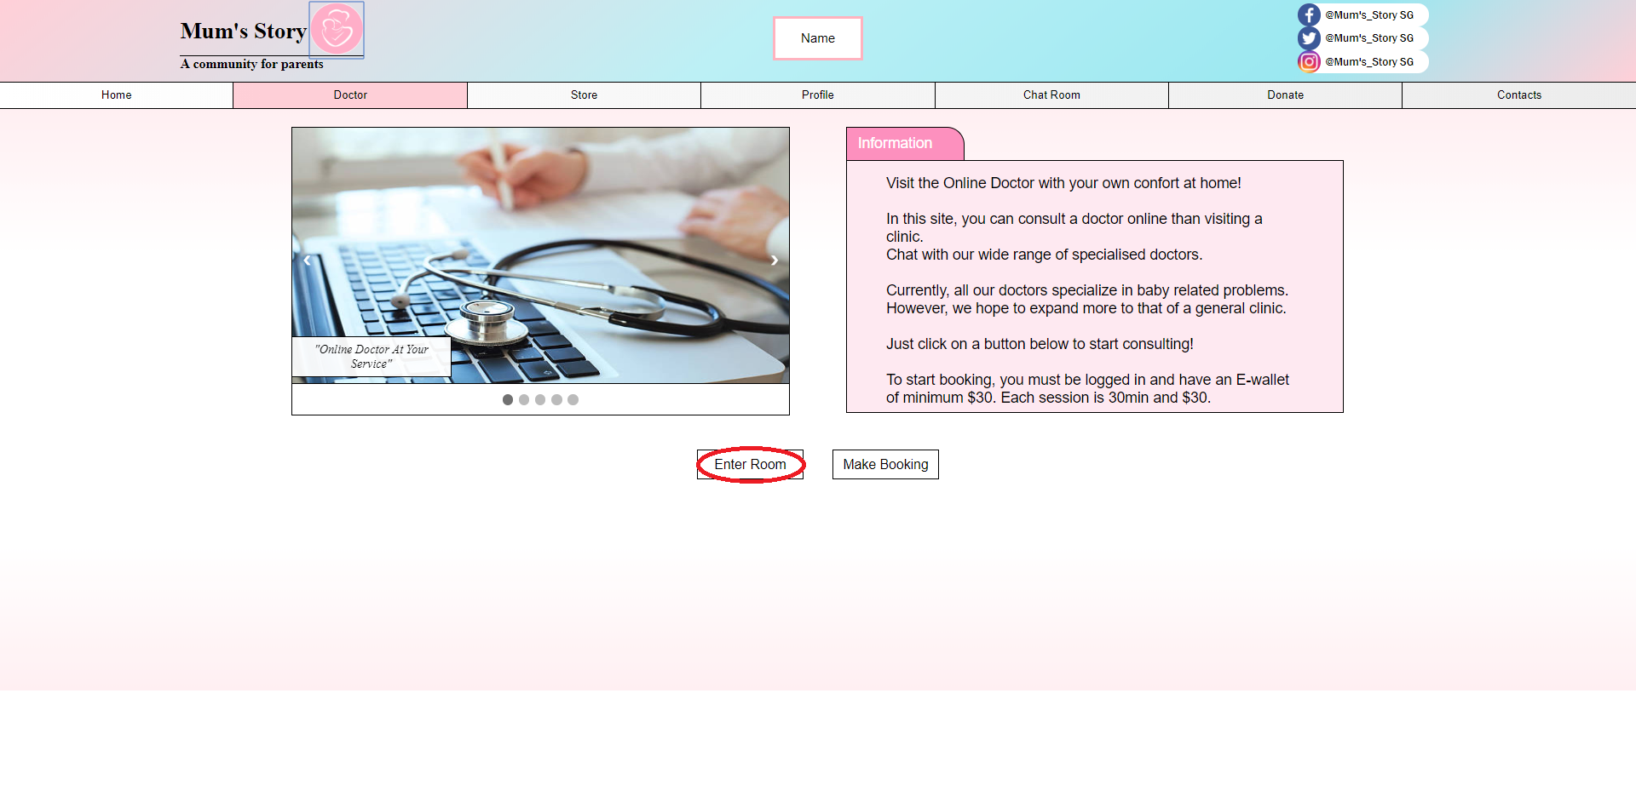

Once the time matches the consultation timing, users have to return back to the Doctor main page and enter room.

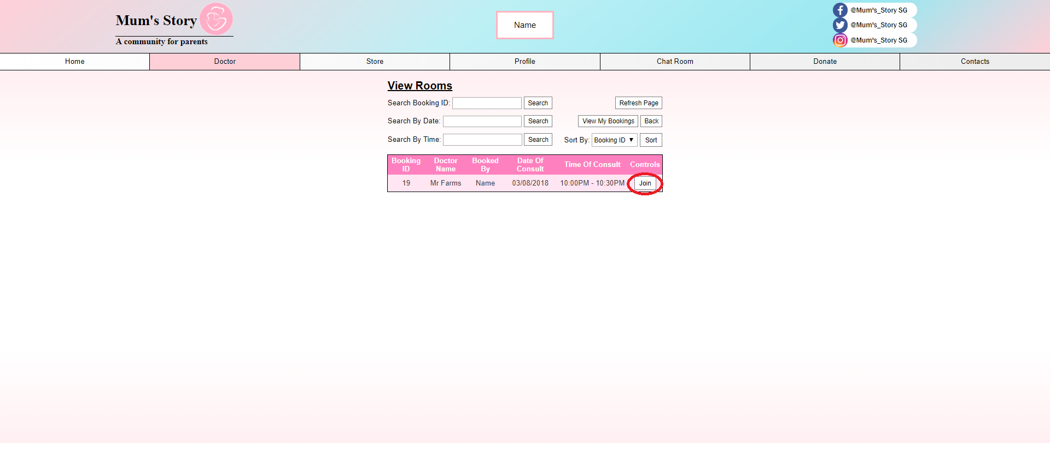

Users can join the session if the doctor if punctual. Else, wait and hit refresh.

Take note that the funds for the online doctor has not yet been deducted.

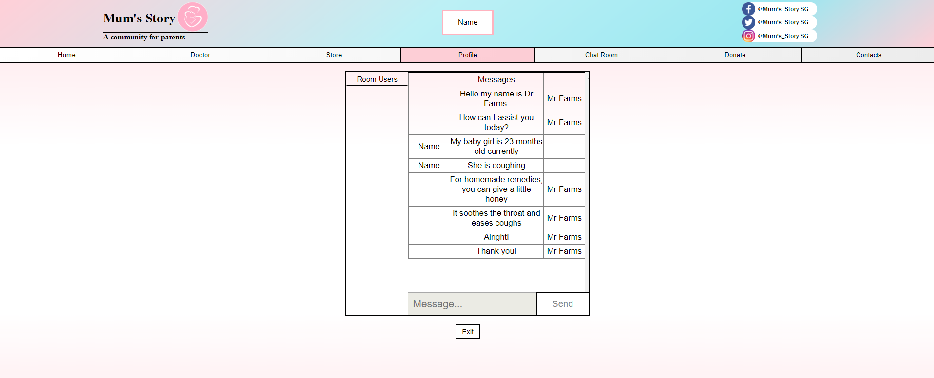

Users can have a chat with the doctors about their worries. Once they are satisfied, they can end the session early by clicking the ‘exit’ button.

**Store**

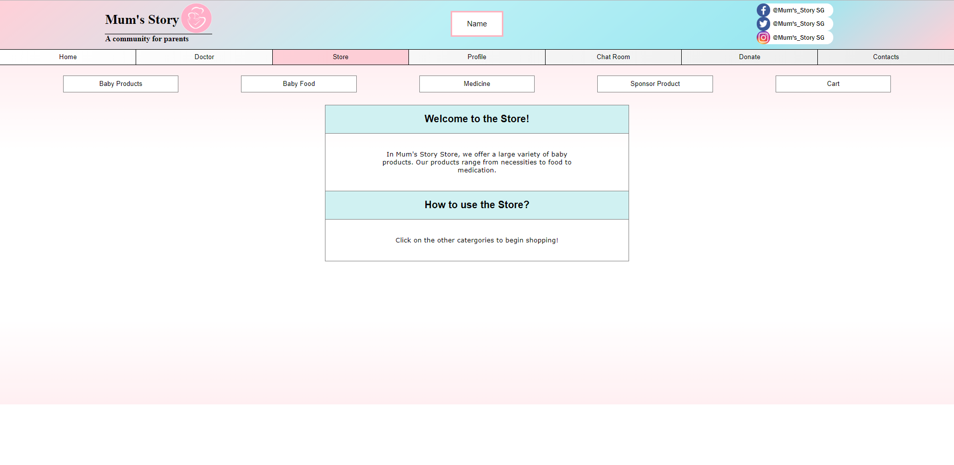

This is the main page for the store. Users can choose the categories of products they wish to purchase. For this demo, we will be choosing the ‘Baby Food’ category.

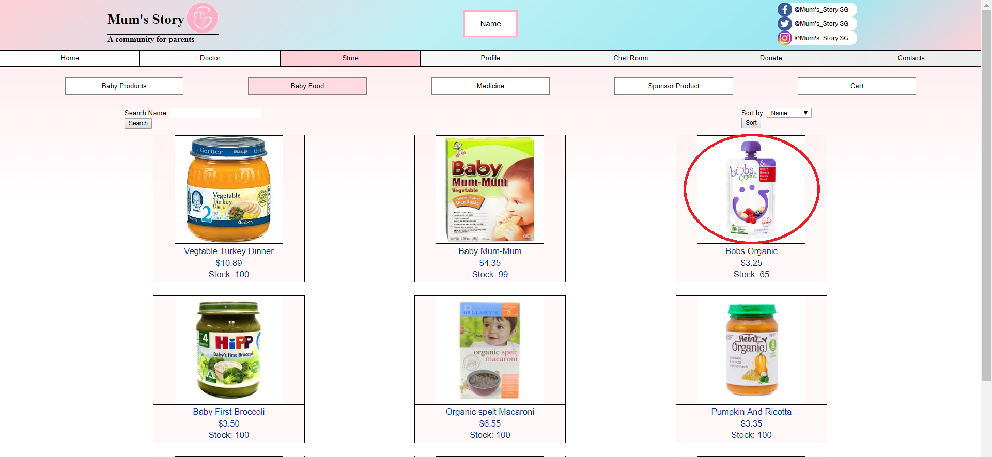

Once in the store, if users wish to purchase the product, they should click the image of the product. They can also search for products on the top left corner.

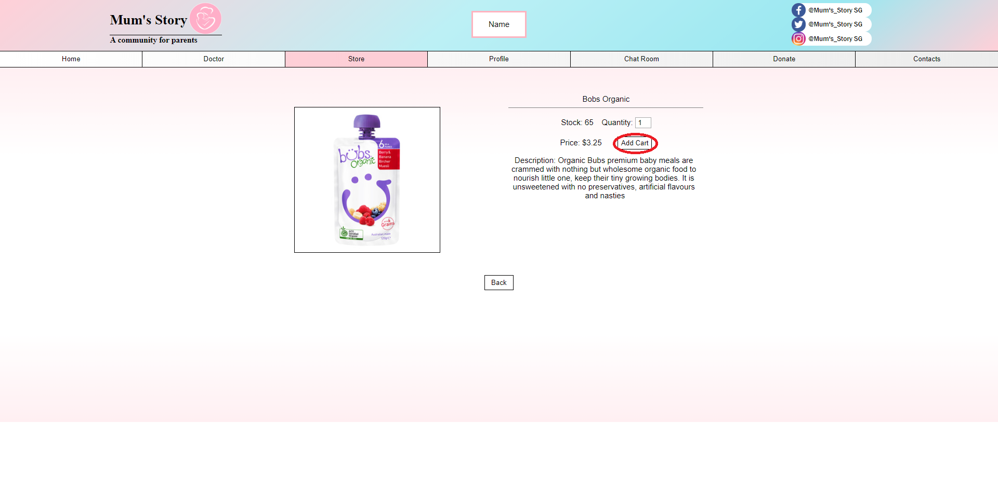

They will be led to a content page of the product with the description of the product. Users can select the amount they wish to purchase by modifying the value in the quantity box. Afterwards, click ‘Add To Cart’. Users have to click back and from there they have to the choice to add in more items or visit the cart.

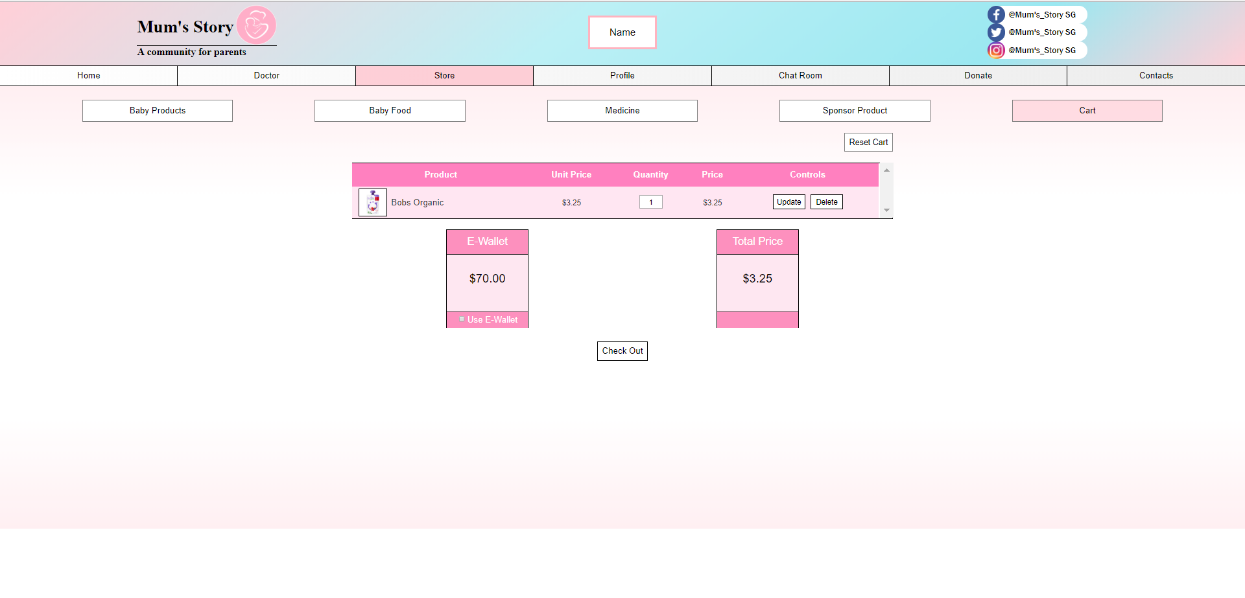

The cart will display all the products that are added. Users can once again edit the quantity of the product by changing the value in the box and hitting the ‘Select’ button.

**Payment**

Users can choose between 2 payments, using the e-wallet or their credit card.

In this case, we assume the user wants to pay by their card.

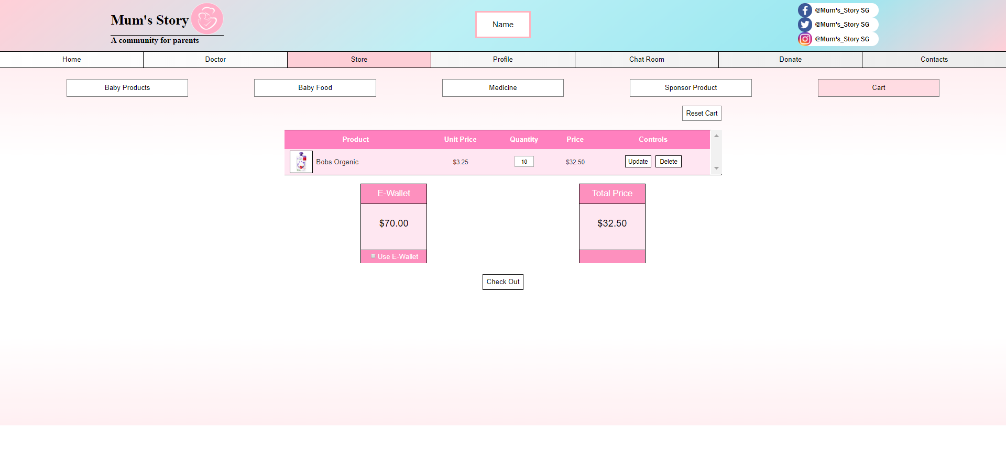

Users have to ensure that the checkbox for beside the “Use E-Wallet” is unticked.

Then click ‘Check Out’.

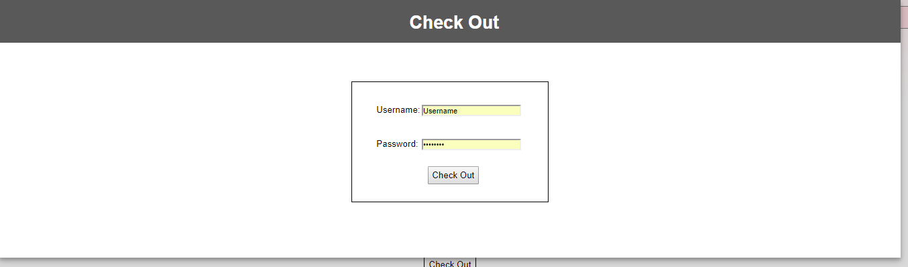

Users will have to login again for verification purposes.

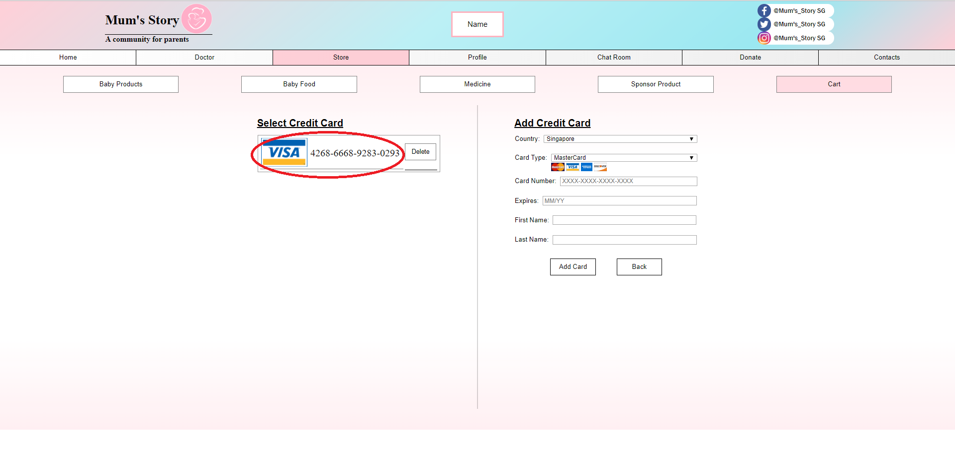

Users can add in a new credit card as shown before or select a saved credit card.

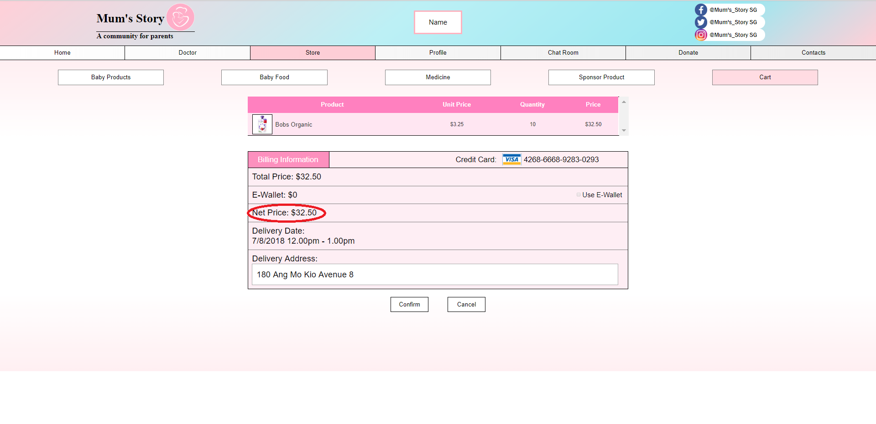

Afterwards, users have to key in their delivery address. Ensure the net price stated is correct before clicking the ‘Confirm’ button.

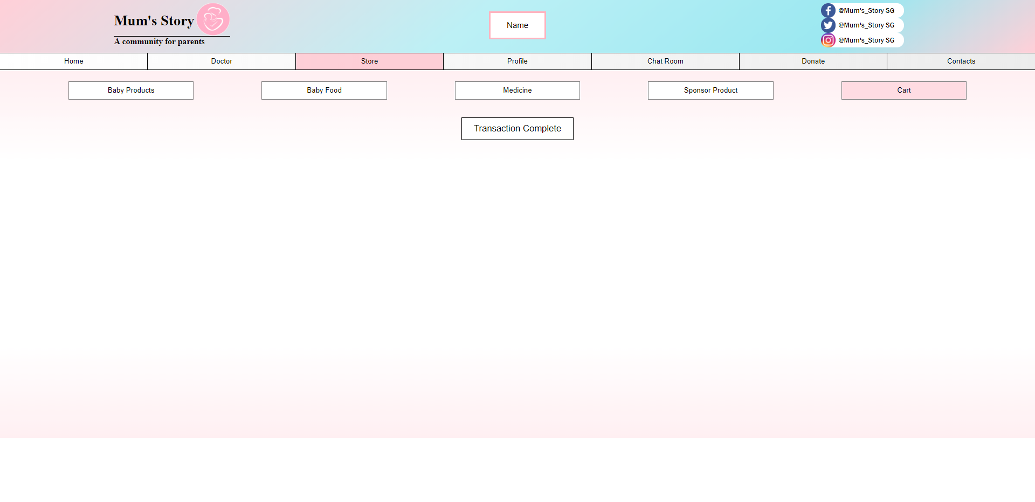

Afterwards, they will be a page stating ‘Transaction Complete’. This means that the payment went through and users should be expecting their products shipped to them soon.

If users wish to pay using the funds in their e-wallet, this is what they should do.

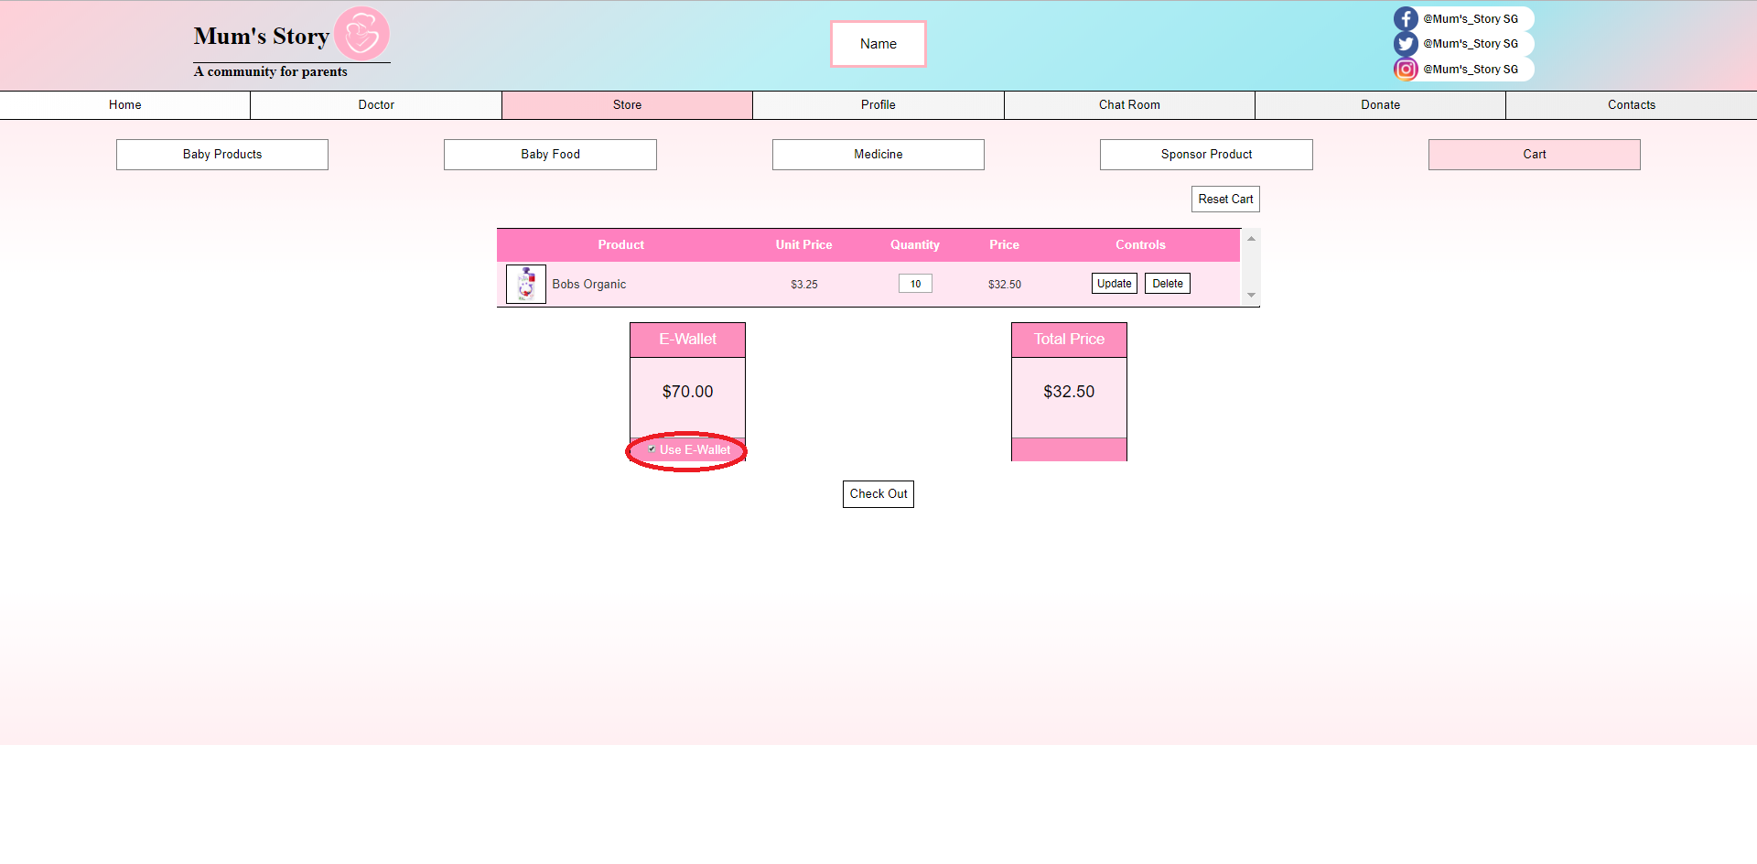

First they should ensure that the ‘Use E-Wallet’ box is ticked before heading to check out.

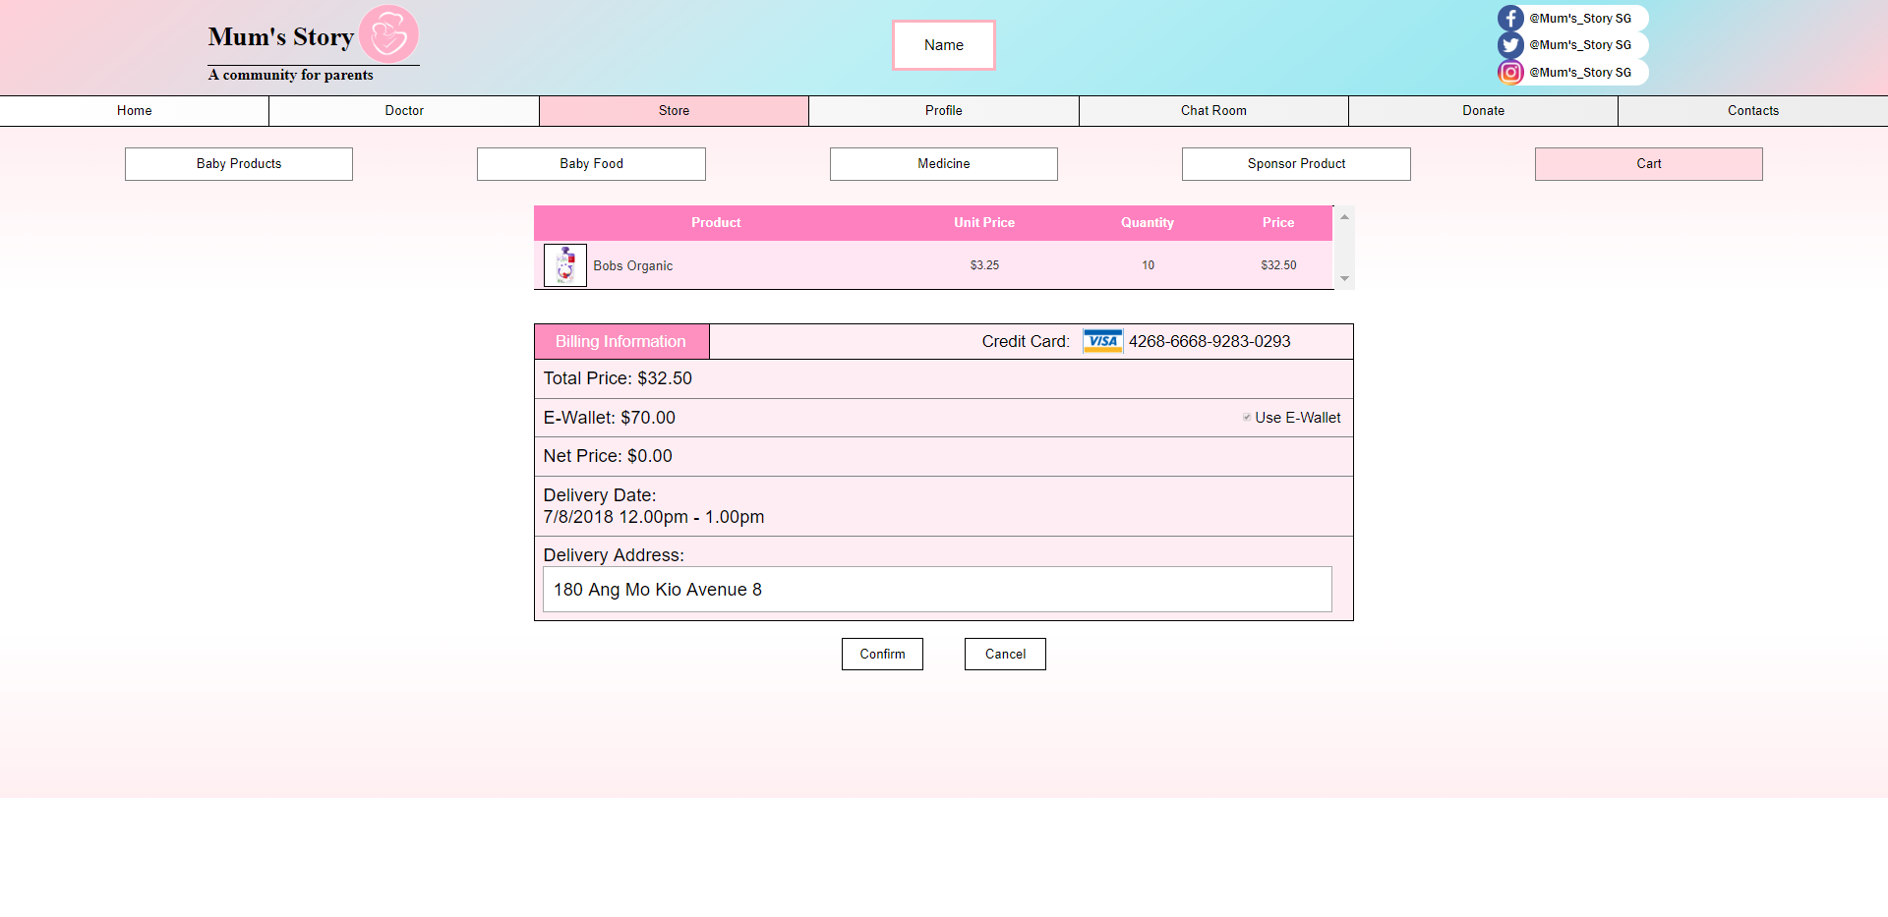

Afterwards, key in their address and hit confirm button. The funds will be deducted automatically from their e-wallet.

**Chat room**

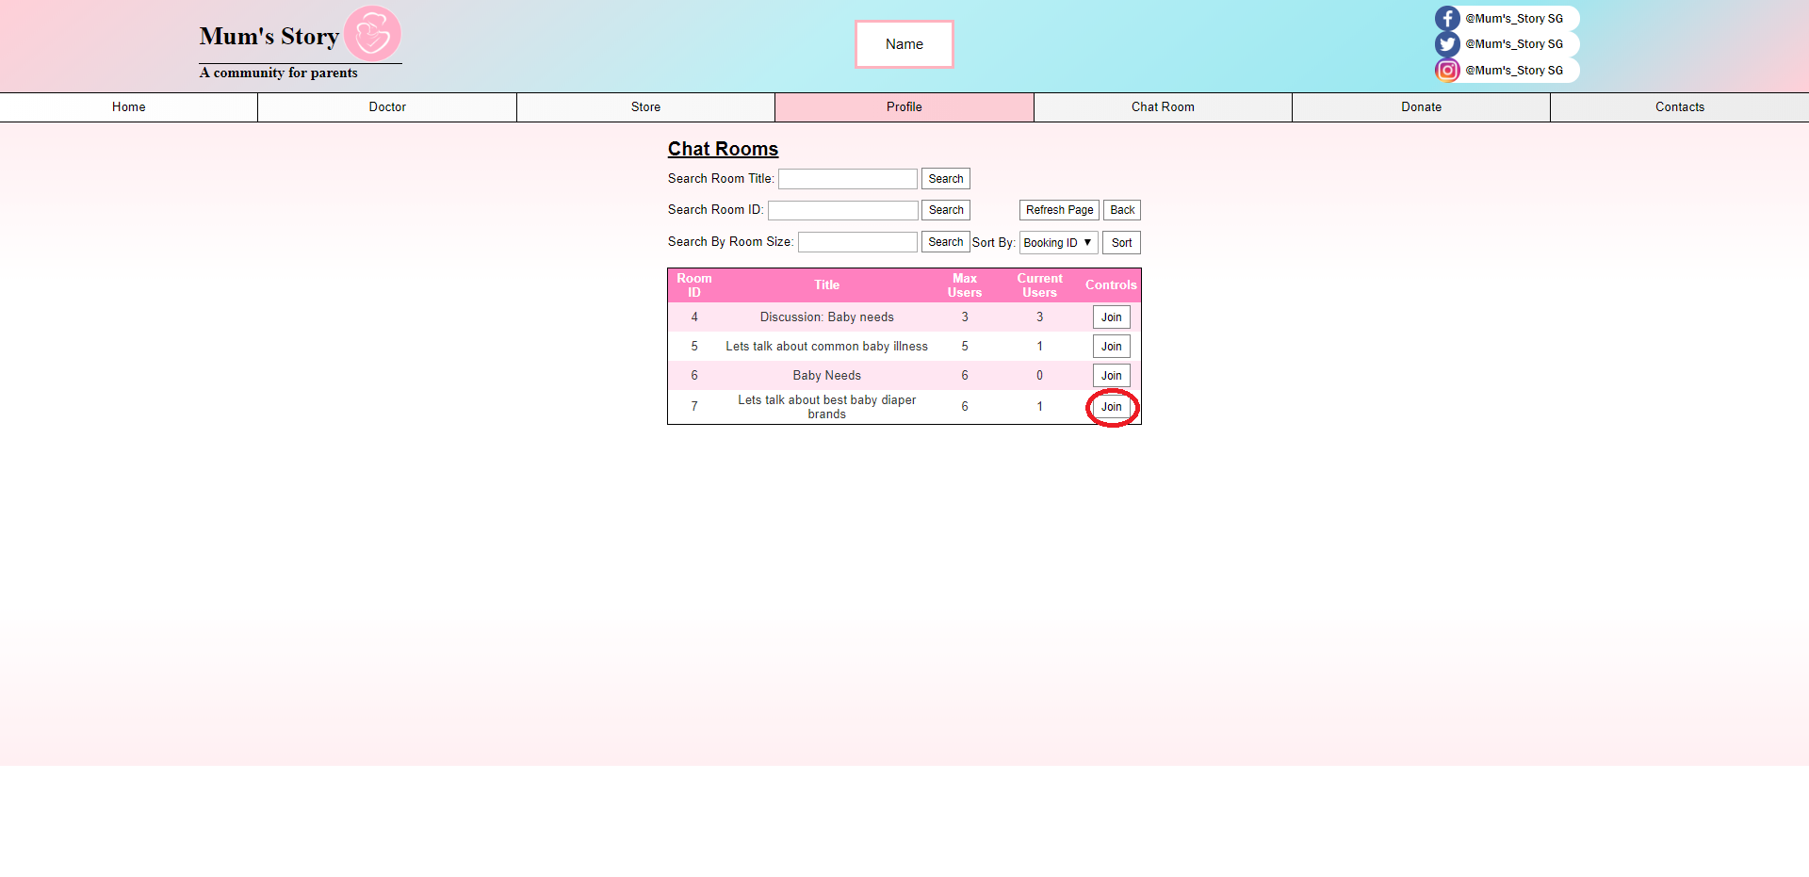

Users can join the chatroom to connect with other users. However, they are unable to create a chat room. If they wish for more chat rooms, feel free to contact the staffs.

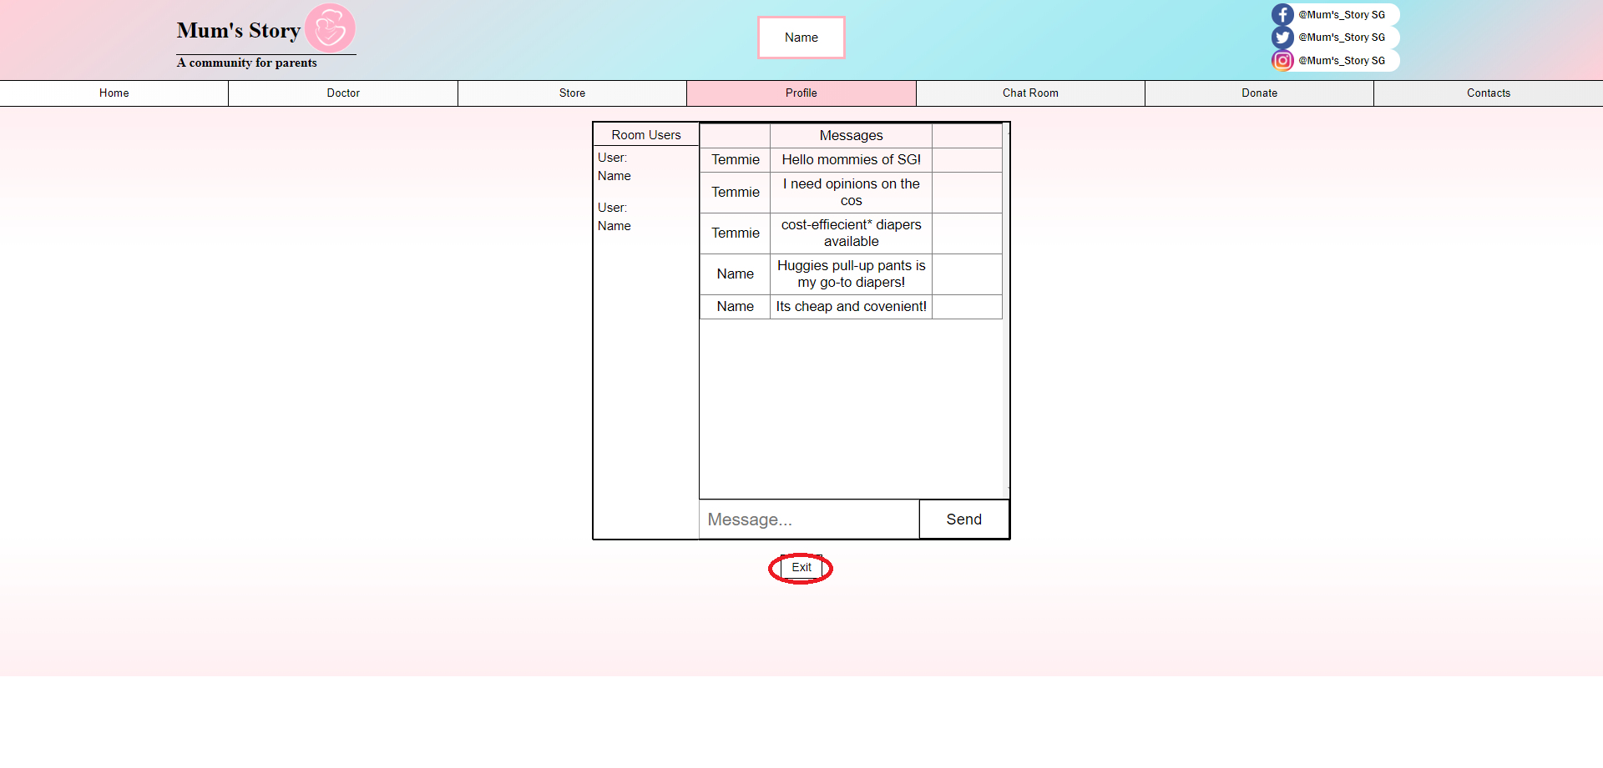

Here is what users should expect in a chat room.

**Donations**

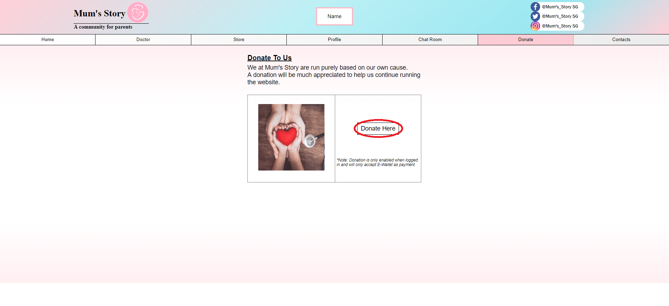

If users are satisfied with Mum’s Story, they could help us out via donations. First and foremost they have to click the ‘Donate Here’ button.

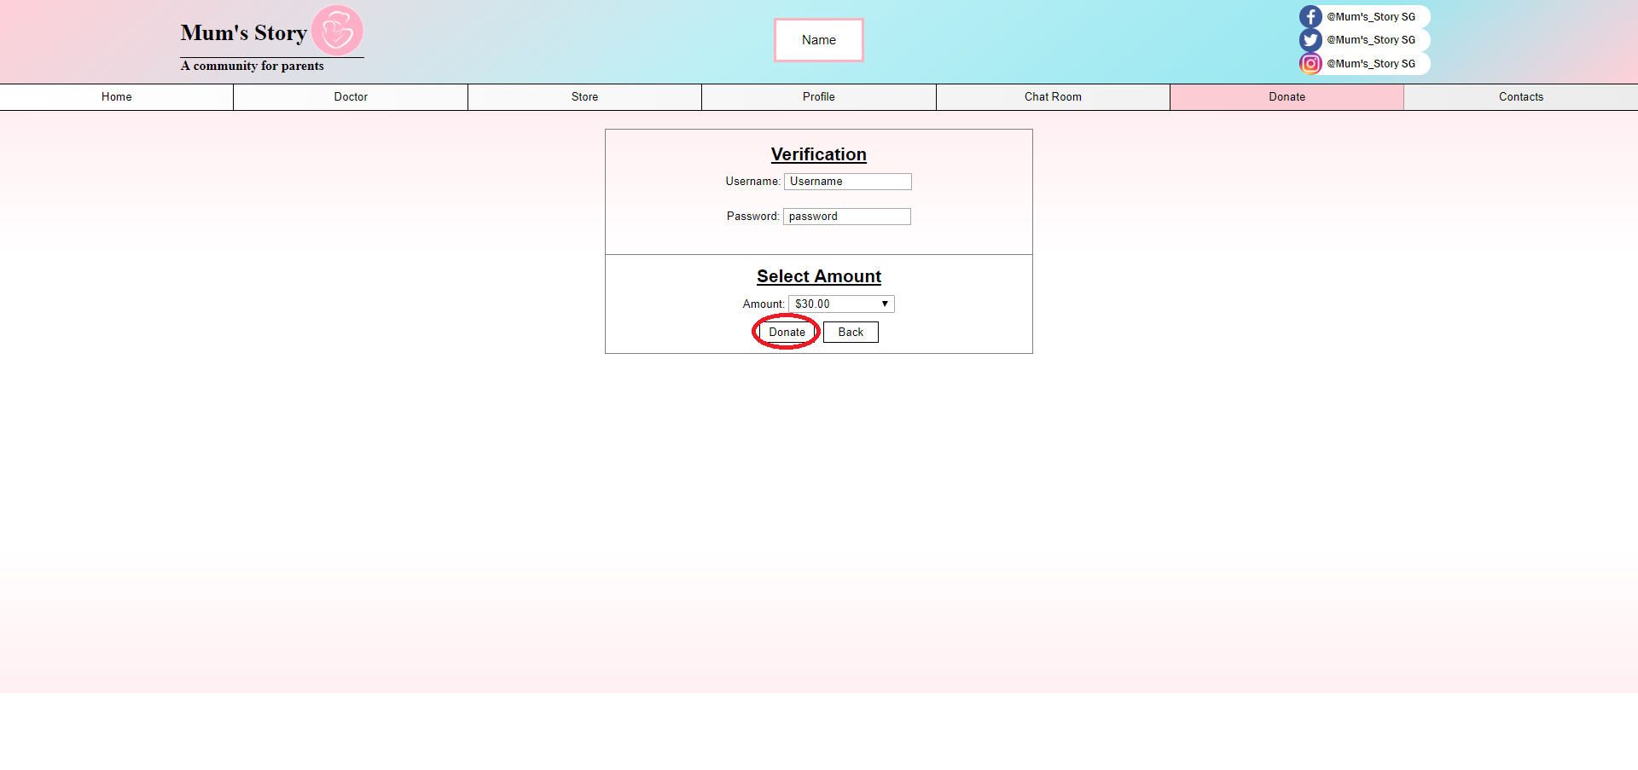

Users have to sign in again for verification and also select the amount they wish to donate. Take note that donations can only be made from the funds in the E-Wallet.

**Transactions**

Users can view their transaction via edit particulars page.

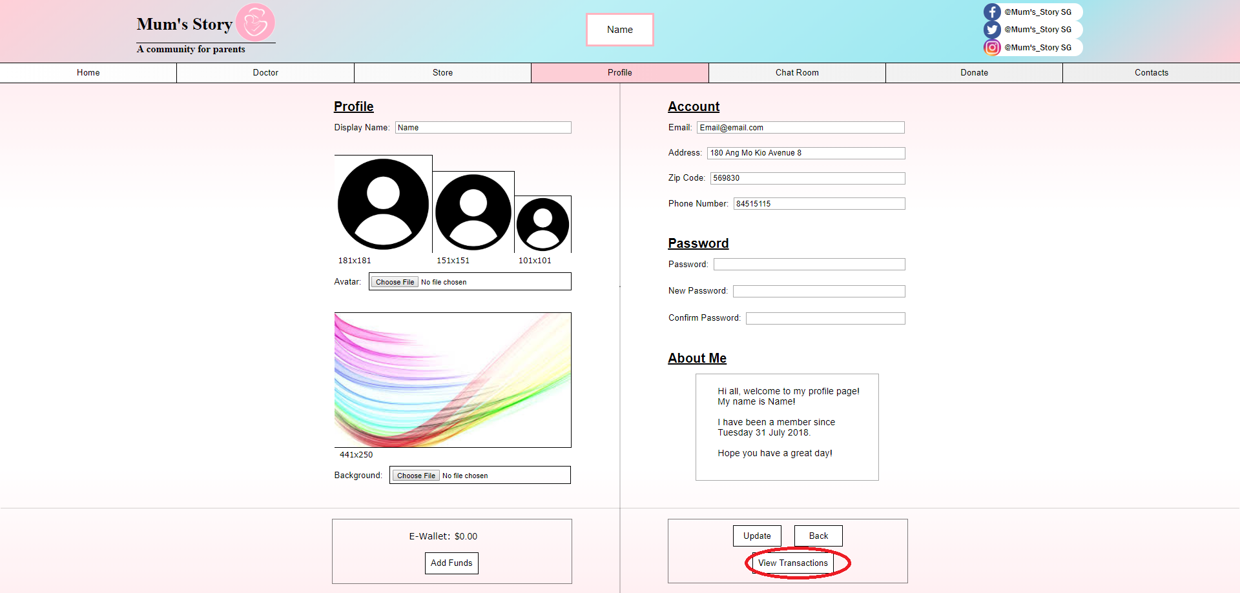

Click the ‘View Transactions’ button.

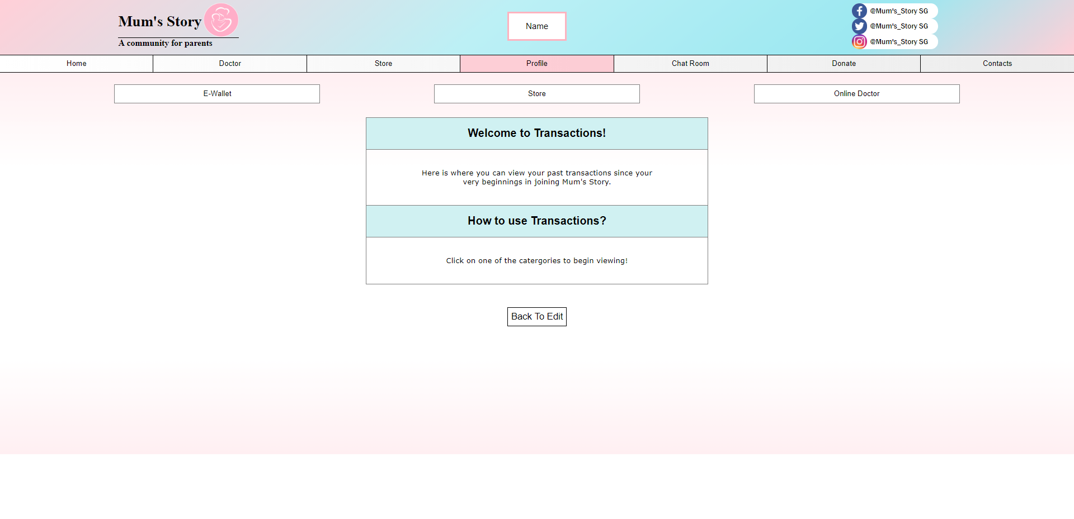

Users can view the E-Wallet, Store or Online Doctor individual transactions.

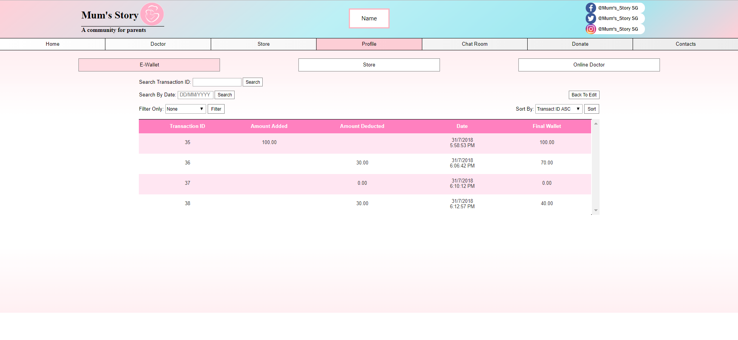

This E-Wallet pages shows how much funds they user has deposited in their account.

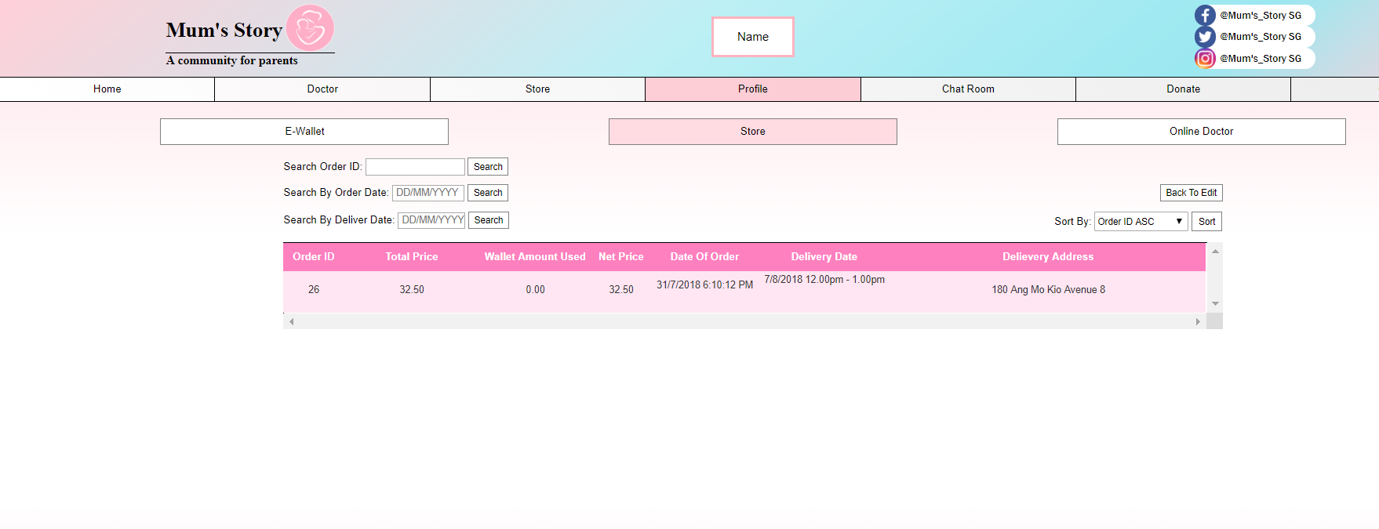

The store transaction page shows the items the user bought from the store.

Users can click the Order ID for a more detailed transaction.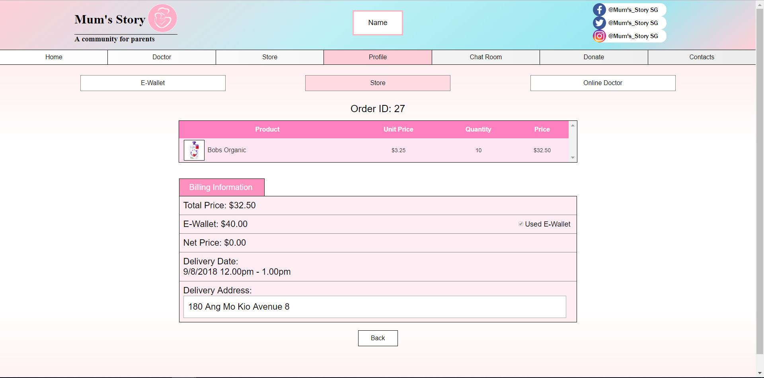

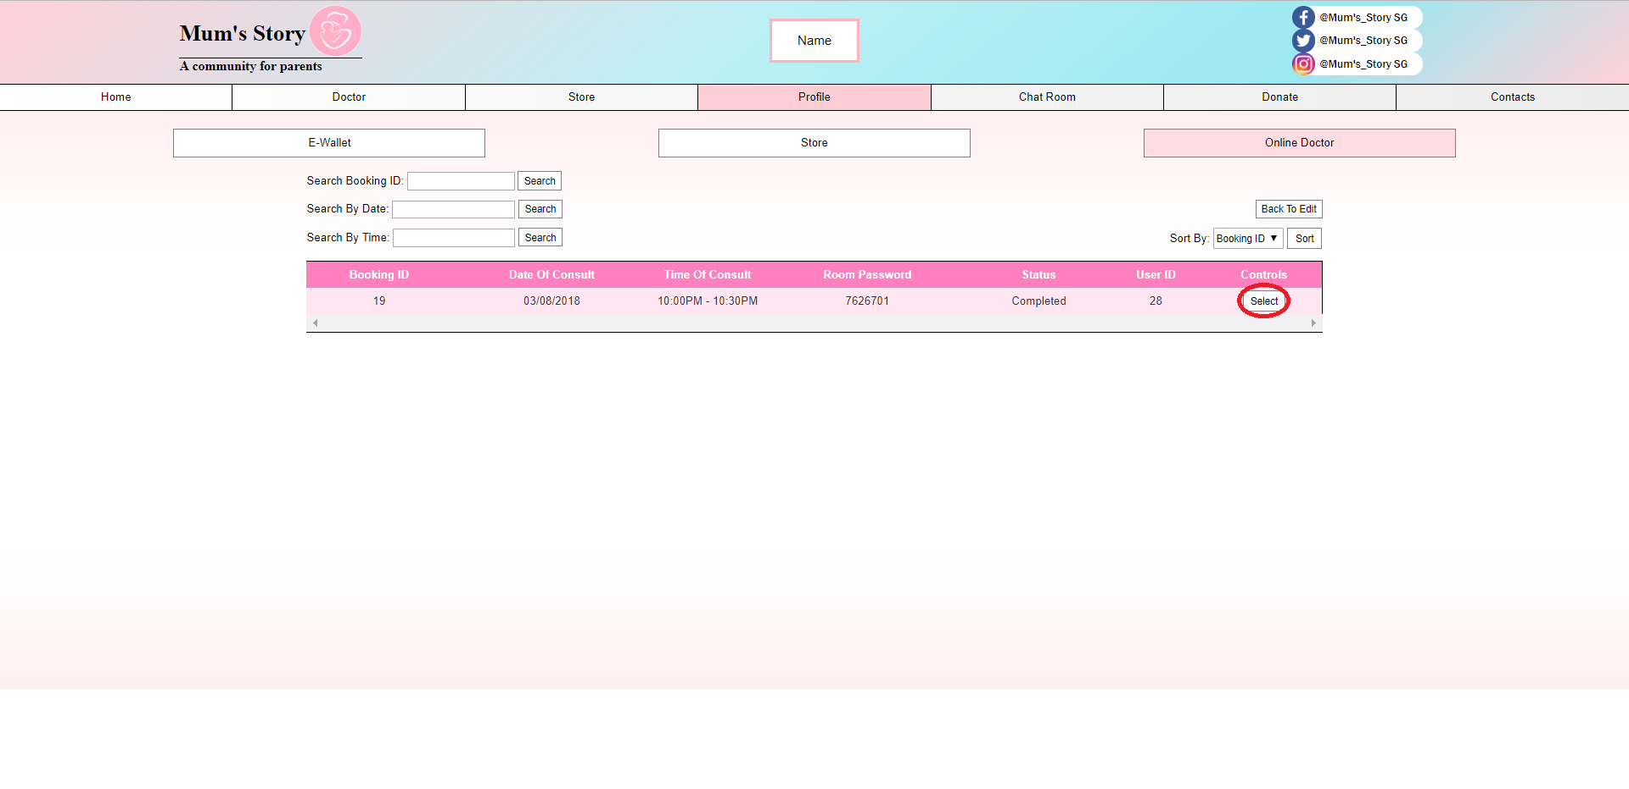

The Online doctor store enables user the view the previous sessions. Furthermore they can click the ‘Select’ button to view the archived chat with the doctor.

**Contacts**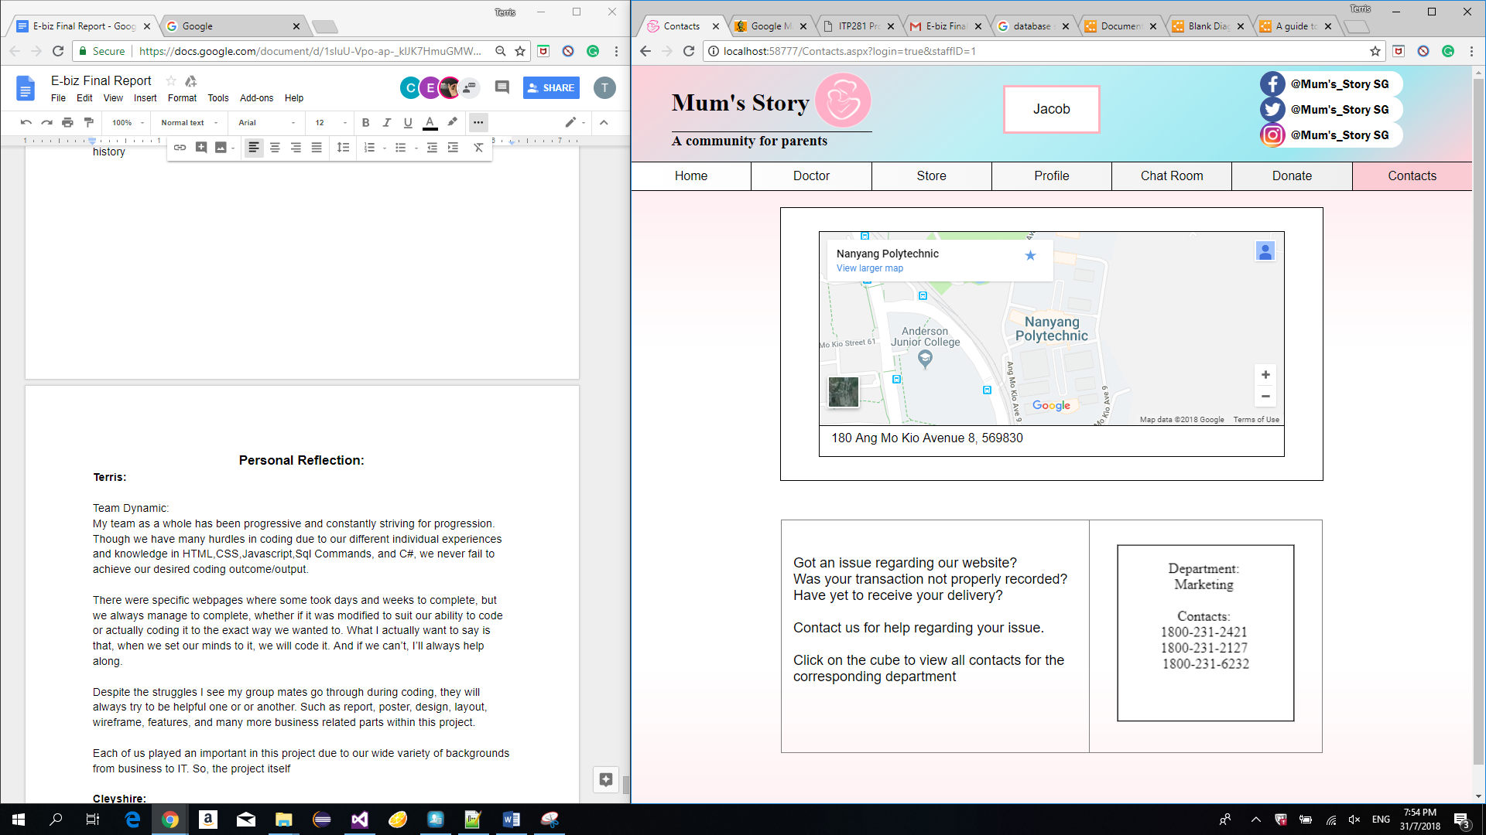

Users can click the contact page to locate us on the map or contact us via the phone numbers.

**Homepage**

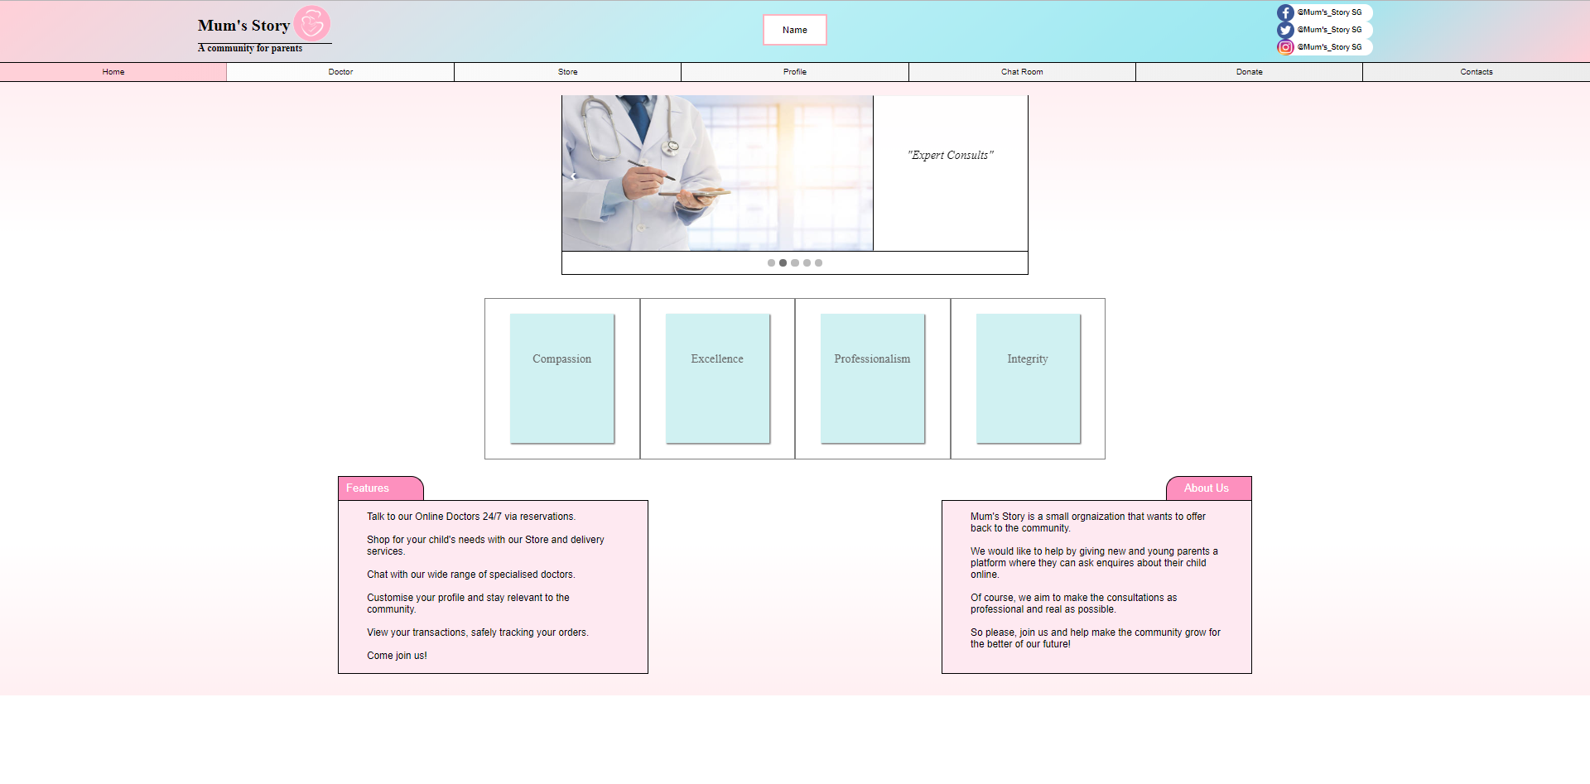

This is the home page.

### **Doctor**

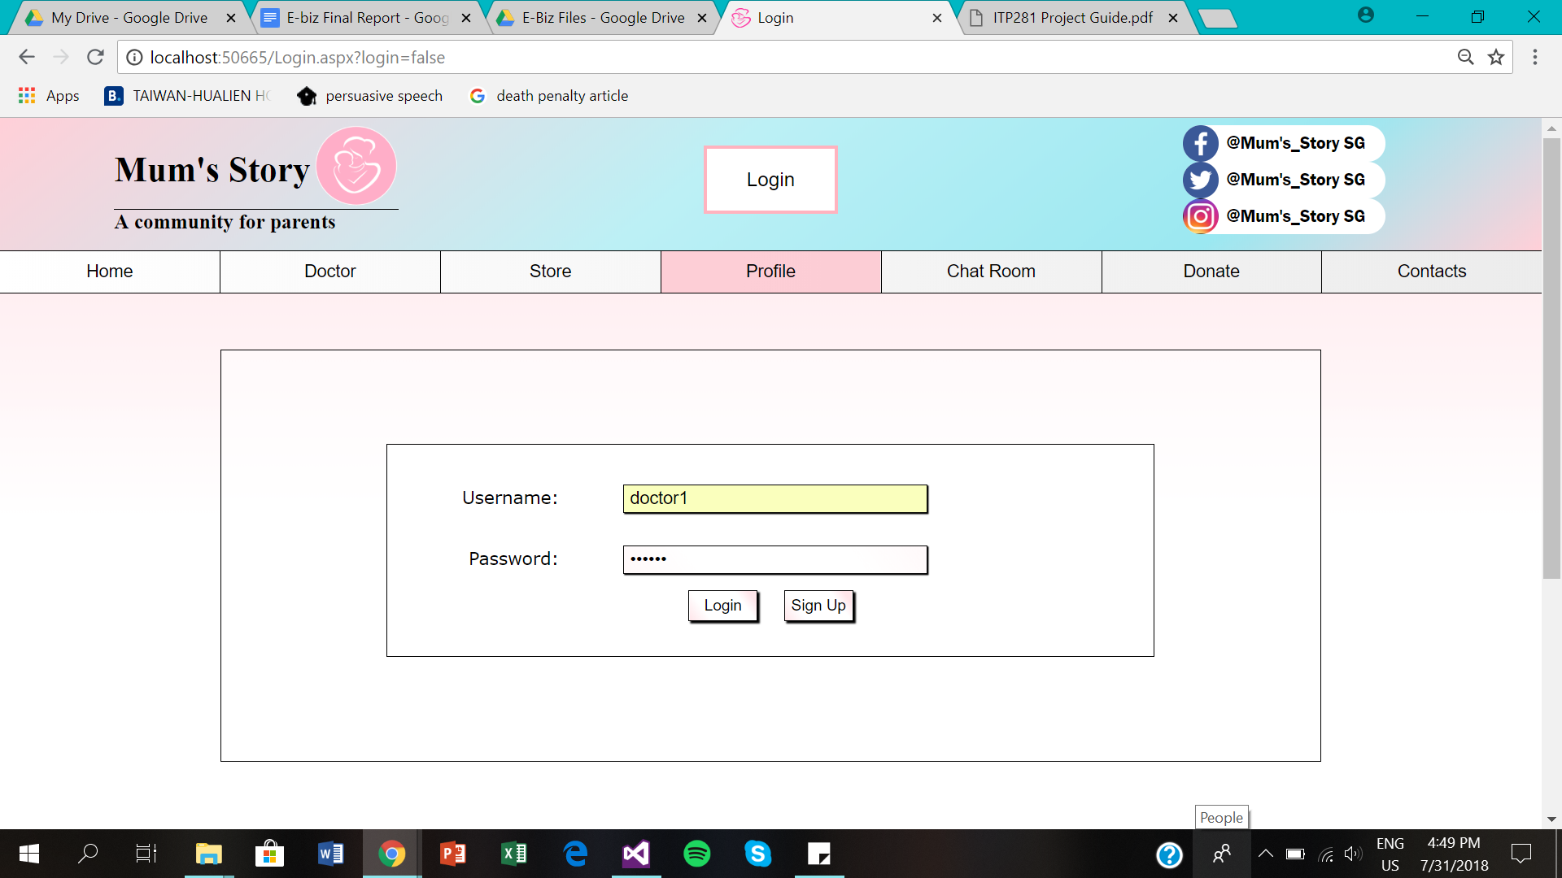

Every doctor account is created by a staff from Mum’s Story.

For a doctor, they will be provided with their login details for their account and this account will enable them to perform their rights as a doctor on Mum’s Story.

1. Doctors will have to log into their account

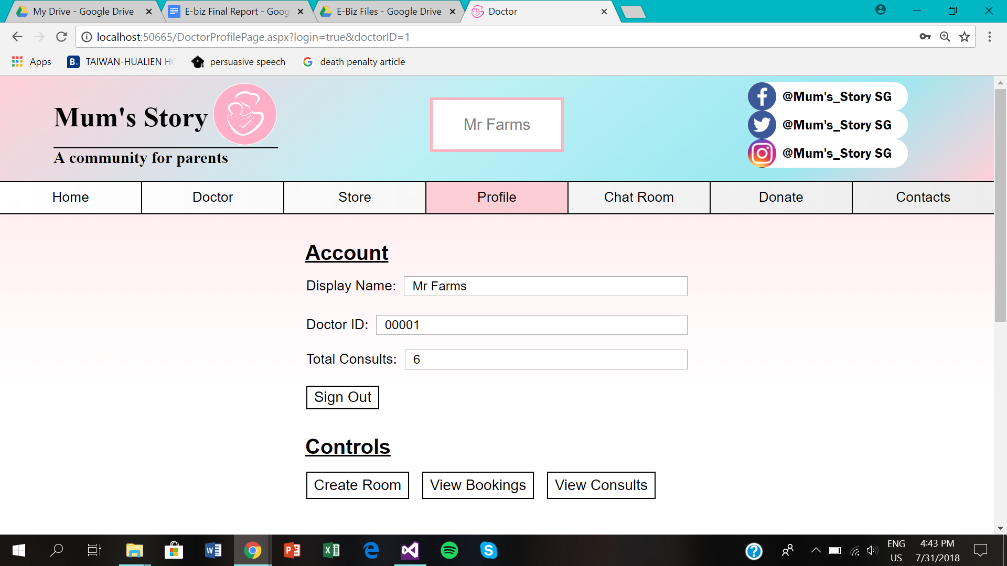

When a doctor logs in, they will see their profile page that will indicate their name, ID and the total number of consults they have completed thus far.

They can choose to perform 3 actions which is to create a room, view their bookings where they can also create a booking or view their past consultations.

**2.** Doctors have to click ‘View Bookings’ in order to view the bookings that they have created or to create a new timeslot.

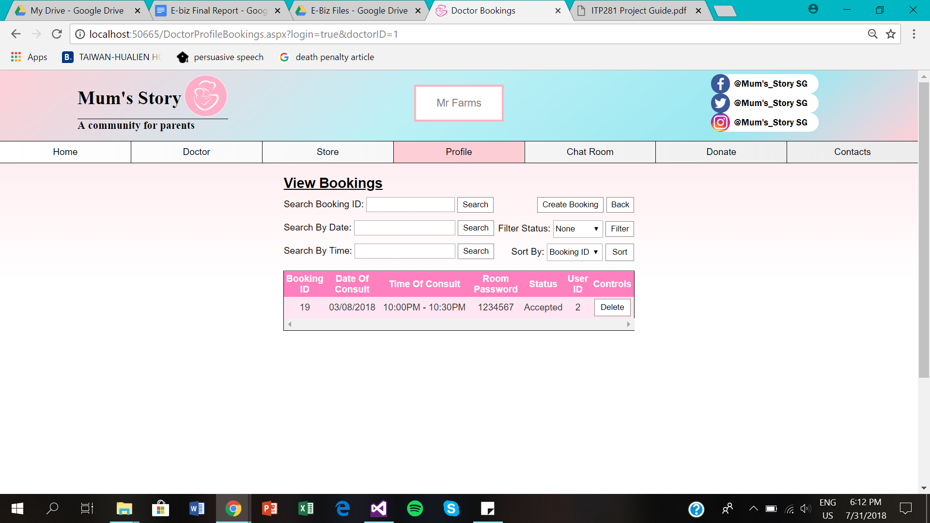

After the doctor click ‘View Bookings’, they will be able to view the time slots that they have previously created where there will be an indication whether the time slot has been booked by a customer.

3. When the doctor wants to create a new time slot, they will have to click ‘Create Booking’

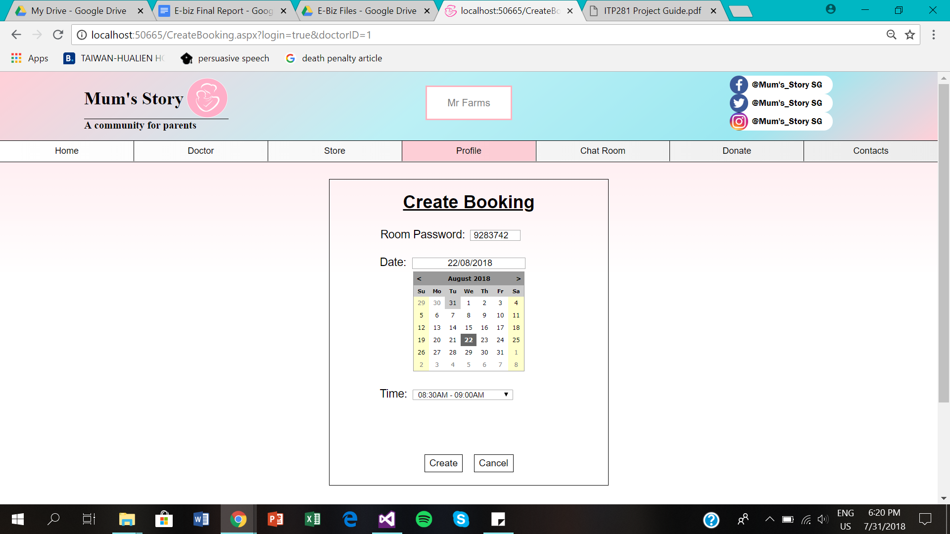

4. At this page, Doctors will have to indicate the room password, date and the time for that particular consultation that they are creating. They will then proceed to click ‘Create’ to create the new time slot and a alert box will alert them when the consultation is successfully created. They will then have to click ‘Cancel’ to exit the page

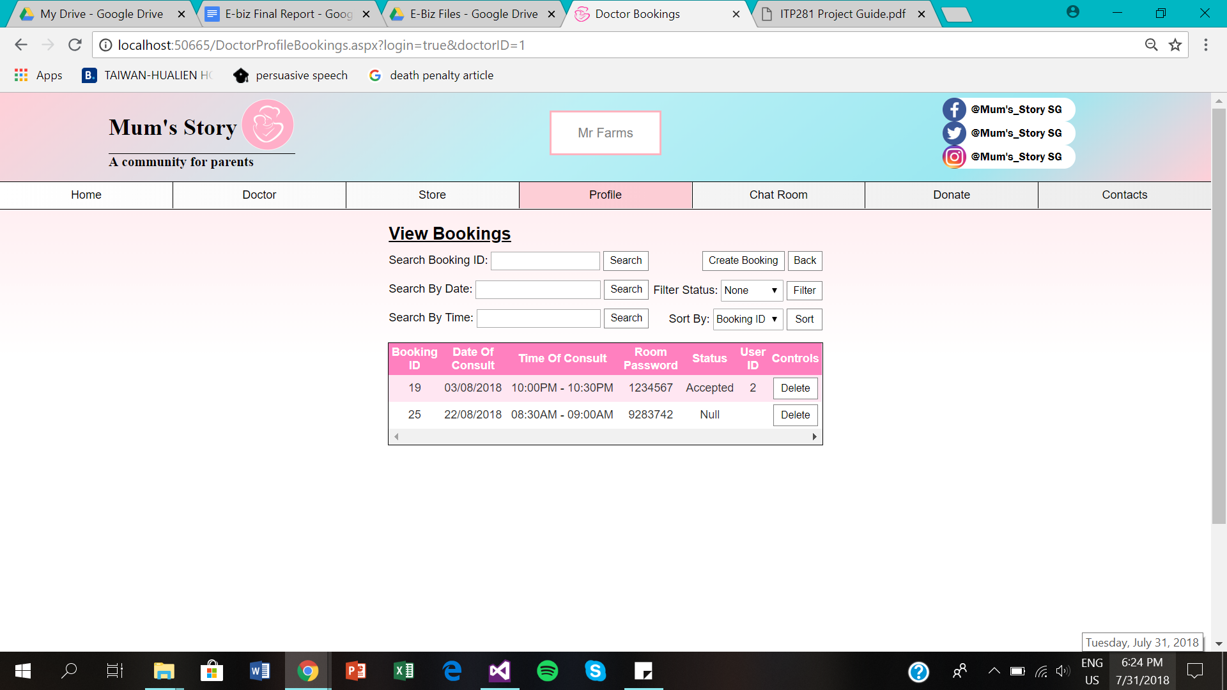

After the doctor successfully create a new consultation, they will be able to view the consultations that they have created on this page. If the consultation is booked, the status will be ‘Accepted’, otherwise it will be null.

5. At this page, doctors will be able to delete consultations that have not been booked. They are also able to filter their consultations based on ID, date or the time of the consultation.

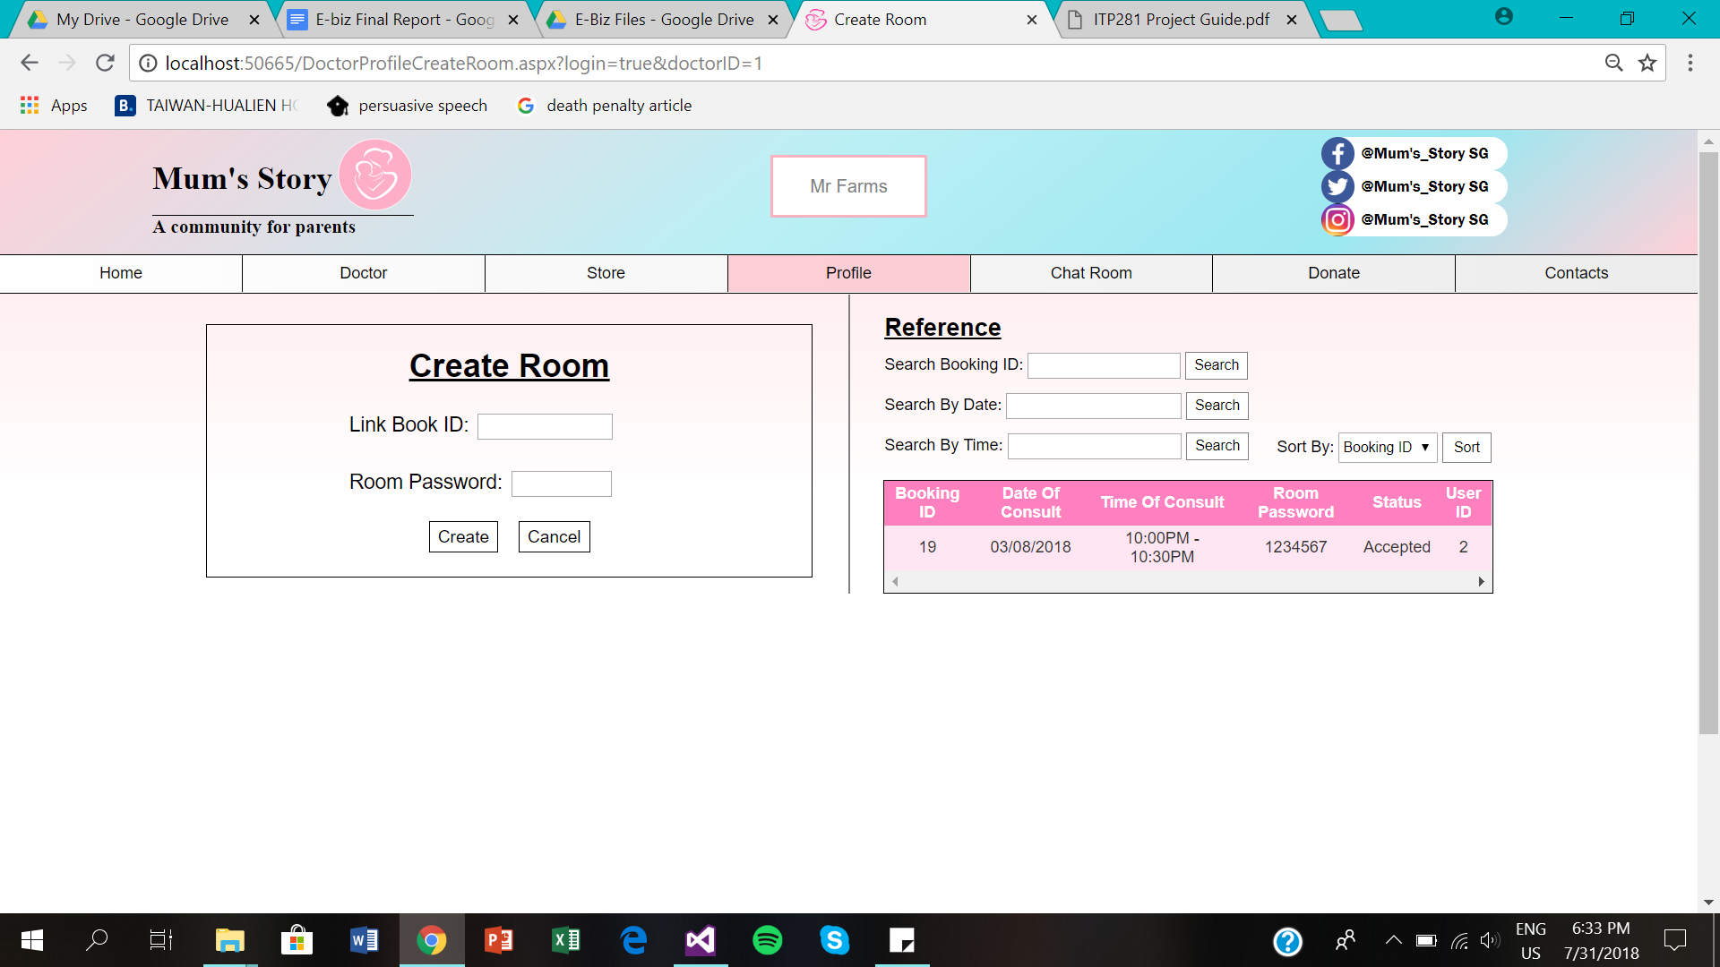

When a doctor has a consultation, they will have to create a chat room before the consultation time for their customers in order for both parties to communicate.

6. They will have to key in the booking ID and the room password based on the reference that will be displayed on the same page. In order to successfully create the room, they will have to click ‘Create’

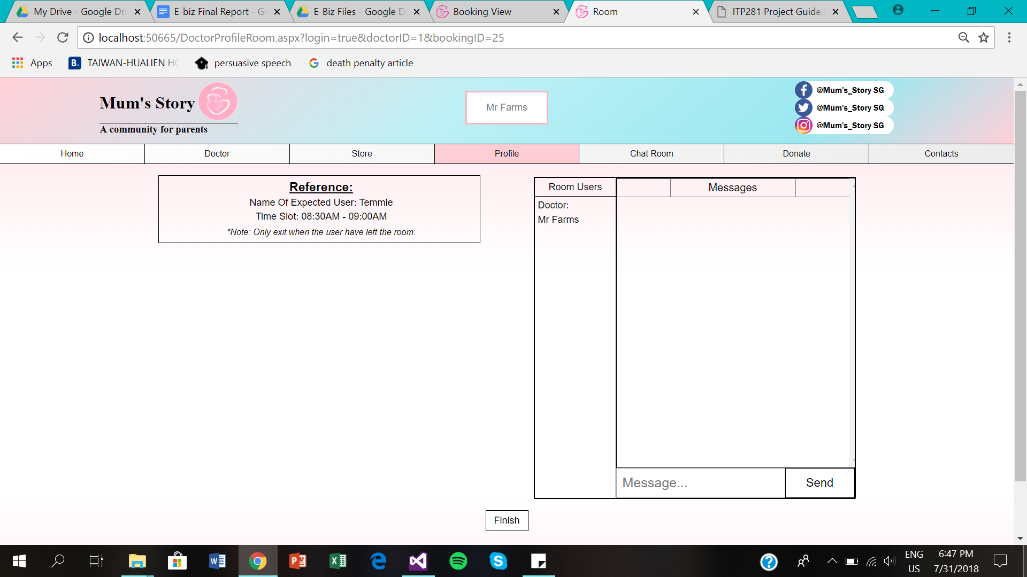

When the doctor create the room, they will be lead into the chat room where they will have to wait for the customer to enter the room in order to start the consultation

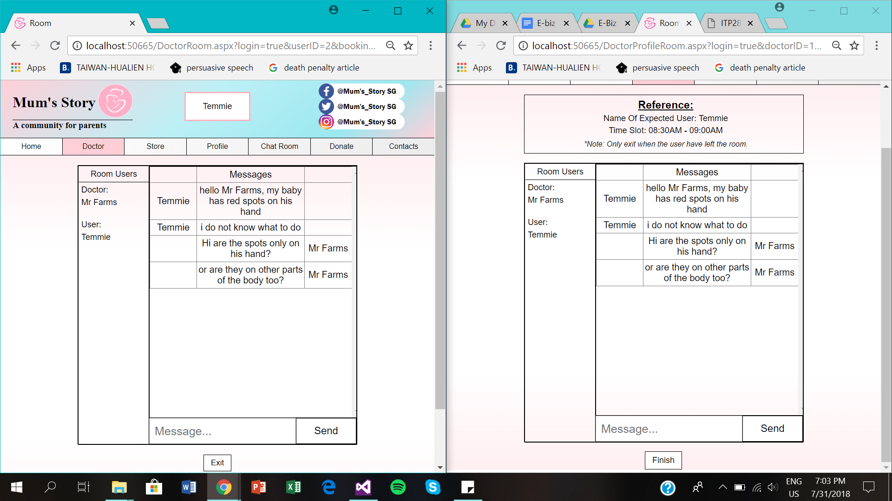

When the customer enters the room, both parties will start the consultation proper

6. Doctors will type their response in the textbox and click ‘Send’

7. When the consultation has ended, doctors will then click ‘Finish’ to end the consultation. **Note: User has to leave the room first before the doctor can leave**

After the consultation has ended, the number of consults will increase on the doctor’s profile page

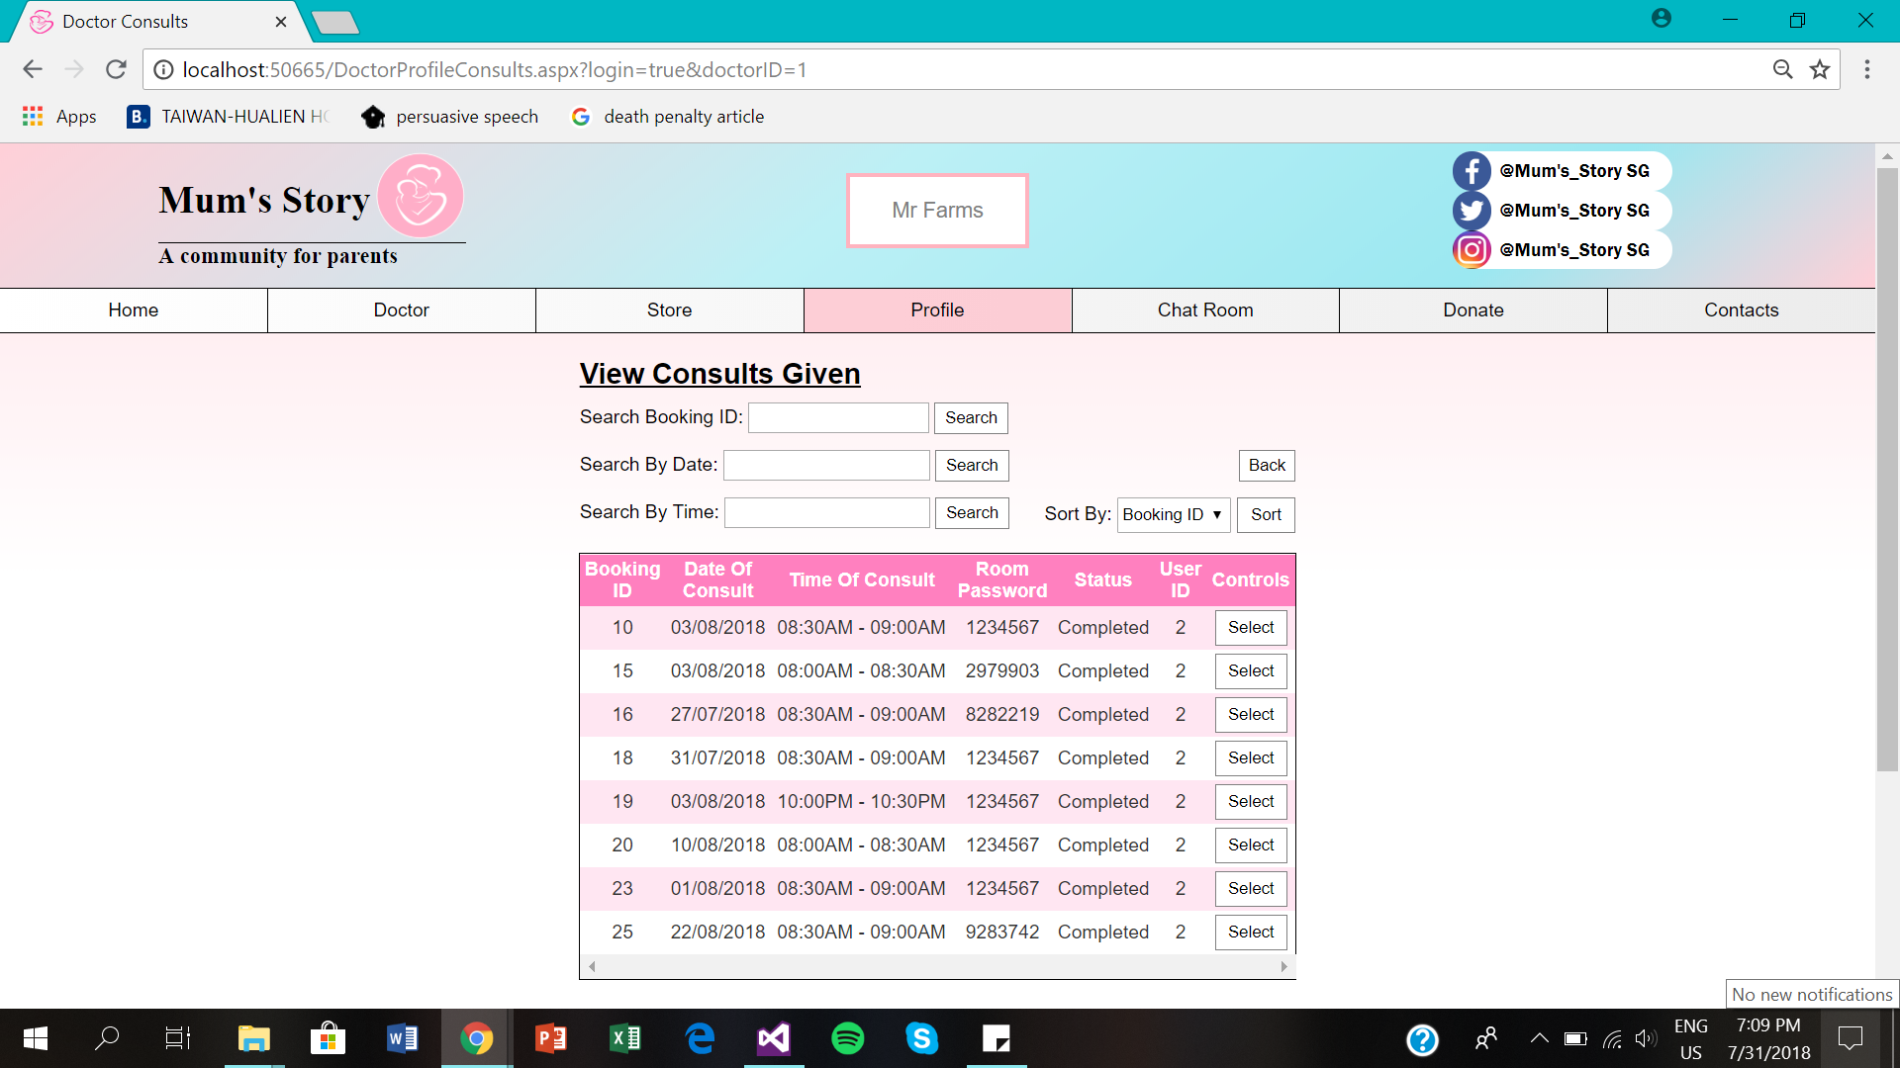

When the doctor wants to view past consultations, they will have to click ‘View consults’ on their profile page and they will be led to this page.

8. Doctors will need to click ‘Select’ in order to view the entire conversation history of their past consultations

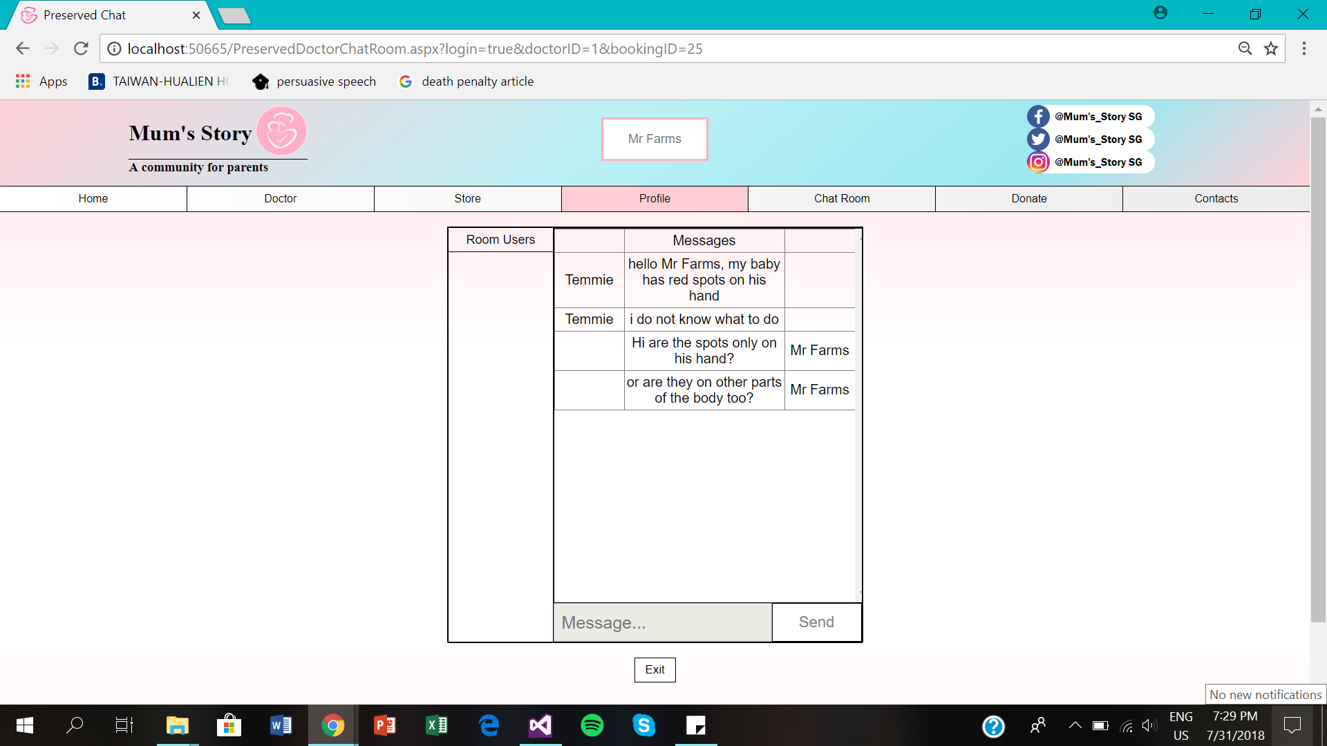

When the doctor select a particular consultation, they will be led to their conversation history where they can view the entire chat

## **Personal Reflection**

### **Terris:**

Team Dynamic:

My team as a whole has been progressive and constantly striving for progression. Though we have many hurdles in coding due to our different individual experiences and knowledge in HTML,CSS,Javascript,Sql Commands, and C#, we never fail to achieve our desired coding outcome/output.

There were specific webpages where some took days and weeks to complete, but we always set ourselves to complete our parts, whether if it was modified to suit our ability to code or actually coding it to the exact way we wanted to. What I actually want to say is that, when we set our minds to it, we will code it. And if we can’t, we will still modify and code it.

Despite the struggles I see my group mates go through during coding, they will always try to be helpful one or or another. Such as report, poster, design, layout, wireframe, features, and many more business related parts within this project.

Each of us played an important role in this project due to our wide variety of backgrounds from business to IT. So, the project itself was not too hard. Not saying it was easy. But we had all-rounded knowledge of the required fields as a whole.

Achievements:

As an individual, I have had many self achievements in this project and still many more after such as better notifications, database attributes, and more.

One achievement was that I was able to code the entire user profile page and staff page with proper validation and database connection, always thinking of the logic and flow. This achievement does not seem much, but being my first webpage I coded that had to handle with database, it was a valuable achievement for me.

Another achievement is coding the doctor room live chat, where a doctor and user is able to communicate with each other. Building a live chat room was actually quite easy. But because of this mindset, I also have doubts that I coded it the correct way.

Another achievement is coding a second chat room but as a group chat. It was satisfying coding it in only 6 hrs. Knowing to myself that i know how to code it.

Key learning points:

Expanding coding knowledge. Learning to use database. Learning how database is very fragile if handled carelessly. Making my first chat room by myself.

### **Cleyshire:**

Team Dynamics:

Our team communicate with each other very well by updating each other on our current progress. We use google docs to share each other’s current progress. When we face problems, we will help each other with our problems.

Achievements:

I faced many problems coding out the web pages due to my lower level of knowledge in programming but i persevered and tried my best to do my individual pages and along the way, i did seek help from my group mates and in the end, we manage to finish the entire program in time. In the end, i was able to finish the booking system and the flow was thought out well.

Key Learning Points:

After going through this project, I have learned many things that are not taught in class. I have learned that the logic and the process behind each web page has to be thought out well. There are many details that needs to be considered in order for the entire flow to sound logical.

### **Elina:**

Team Dynamic:

Our group members have shown a great teamwork skills and also are very cooperative towards one another. We have learn to help one another when someone is in need of help and we are willing to compromise to one another. Not only that, our team also placed in our 100% effort in our work and also we always complete our task before our dateline.

Achievements

I started off without knowing what to expect from the coding process. However, gradually, I came to learn how to create the design view in the aspx file and also link the buttons together. Not only that, I also learn how to create database for each objects which will be used in our project.

Key Learning Points

Through this project, I have learnt that self learn outside of the class is very important. Therefore, I realise the importance of being able to solve the errors through the continuous of researching and watching videos. I also understand that one has to plan out the algorithm well before executing it.

### **Adil:**

Team Dynamic:

Our team had a great productive meetings on what needs to be done before anyone starts anything. We also share our individual progresses on the website on Google Drive as reference for the rest. We made sure everyone was on par on what was going on.

Key Learning Points:

I learn more about the wonders of coding and how websites work. I also understand the importance of keeping a solid database and the importance of backup files.

Achievements:

I created web pages that can connect to a database unlike the previous year. I consider it a stepping stone for me to success.

## **Appendix**